|  |
| --- |
| English |
| **Breakthrough Methodology**  **Business Process Procedure** |
|  |
|  |
|  |

Batch

|  |  |
| --- | --- |
| Breakthrough Methodology  July March 2001 2009  EnglishEnglish |  |

### 

Project: CDO Foodsphere Inc.

Prepared By: Michael Mendoza Mella

Strictly Confidential

#### Icons

|  |  |
| --- | --- |
| Icon | Meaning |
| achtung | Caution |
| example | Example |
| tip | Note |
| recommen | Recommendation |
| syntaxic | Syntax |

#### Typographic Conventions

|  |  |
| --- | --- |
| Type Style | Description |
| Example text | Words or characters that appear on the screen. These include field names, screen titles, pushbuttons as well as menu names, paths and options.  Cross-references to other documentation. |
| Example text | Emphasized words or phrases in body text, titles of graphics and tables. |
| EXAMPLE TEXT | Names of elements in the system. These include report names, program names, transaction codes, table names, and individual key words of a programming language, when surrounded by body text, for example, SELECT and INCLUDE. |
| Example text | Screen output. This includes file and directory names and their paths, messages, source code, names of variables and parameters as well as names of installation, upgrade and database tools. |
| EXAMPLE TEXT | Keys on the keyboard, for example, function keys (such as F2) or the ENTER key. |
| Example text | Exact user entry. These are words or characters that you enter in the system exactly as they appear in the documentation. |
| <Example text> | Variable user entry. Pointed brackets indicate that you replace these words and characters with appropriate entries. |

# 

# 

# Create Batch

**Use**

This activity is used to manually create a new batch for a specific material.

**Procedure**

1. Access the transaction using following navigation options:

|  |  |
| --- | --- |
| **SAP ECC Menu** | Logistics → Materials Management → Material Master → Batch → Create |
| **Transaction code** | MSC1N |

1. On *Create Batch Screen*, make the following entries:

|  |  |  |
| --- | --- | --- |
| **Field Name** | **User action and values** | **Comment** |
| Material | Required | Alphanumeric key uniquely identifying the [material](SAPEVENT:DOCU_LINK\DS:GLOS.material). |
| Batch | Required | Assigns a [material](SAPEVENT:DOCU_LINK\DS:GLOS.3526BEB5AFAB52B9E10000009B38F974) that is manufactured in batches or production lots to a specific [batch](SAPEVENT:DOCU_LINK\DS:GLOS.3526BFBFAFAB52B9E10000009B38F974). |
| Plant | Required | Key uniquely identifying a [plant](SAPEVENT:DOCU_LINK\DS:GLOS.plant). |
| Stor. Location | Required | Number of the [storage location](SAPEVENT:DOCU_LINK\GL:storage_location) at which the material is stored. A [plant](SAPEVENT:DOCU_LINK\GL:plant) may contain one or more storage locations. |

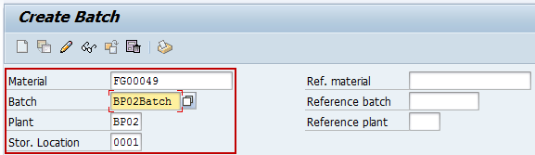

1. Press **Enter** key. Batch will be classified automatically.



1. Click *Save*  icon to save the batch.

C:\Users\misojt\AppData\Local\Temp\SNAGHTML1042c23.PNG

**Result**

Batch for the material has been created.



tip To view the created batch.

1. To view the created batch access the transaction using following navigation options:

|  |  |
| --- | --- |
| **SAP ECC Menu** | Logistics → Materials Management → Material Master → Other → Stock Overview |
| **Transaction code** | MMBE |

1. On *Stock Overview: Company Code/Plant/Storage Location/Batch Screen,* make the following entries:

|  |  |  |
| --- | --- | --- |
| **Field Name** | **User action and values** | **Comment** |
| Material | Required | Alphanumeric key uniquely identifying the [material](SAPEVENT:DOCU_LINK\DS:GLOS.material) |
| Plant | Required | Key uniquely identifying a [plant](SAPEVENT:DOCU_LINK\DS:GLOS.plant). |
| Stor. Location | Required | Number of the [storage location](SAPEVENT:DOCU_LINK\GL:storage_location) at which the material is stored. A [plant](SAPEVENT:DOCU_LINK\GL:plant) may contain one or more storage locations. |
| Batch | Required | Assigns a [material](SAPEVENT:DOCU_LINK\DS:GLOS.3526BEB5AFAB52B9E10000009B38F974) that is manufactured in batches or production lots to a specific [batch](SAPEVENT:DOCU_LINK\DS:GLOS.3526BFBFAFAB52B9E10000009B38F974). |

1. Click *Execute*  icon or press F8.
2. On *Stock Overview:Basic List Screen*, you will see the batch you created.

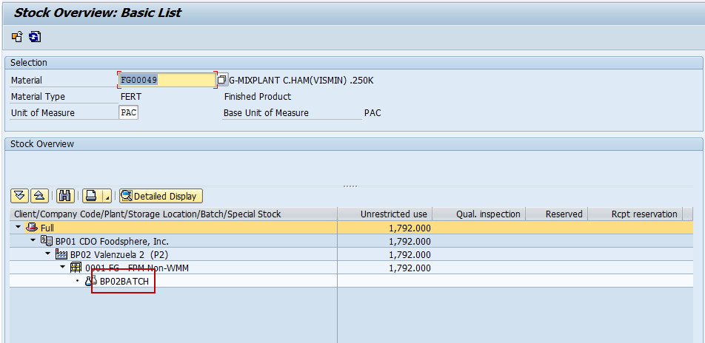

# Change / Delete Batch

**Use**

This activity is used to change/delete a batch.

**Procedure**

1. Access the transaction using following navigation options:

|  |  |
| --- | --- |
| **SAP ECC Menu** | Logistics → Materials Management → Material Master → Batch → Change |
| **Transaction code** | MSC2N |

1. On *Create Batch Screen*, make the following entries:

|  |  |  |
| --- | --- | --- |
| **Field Name** | **User action and values** | **Comment** |
| Material | Required | Alphanumeric key uniquely identifying the [material](SAPEVENT:DOCU_LINK\DS:GLOS.material). |
| Batch | Required | Assigns a [material](SAPEVENT:DOCU_LINK\DS:GLOS.3526BEB5AFAB52B9E10000009B38F974) that is manufactured in batches or production lots to a specific [batch](SAPEVENT:DOCU_LINK\DS:GLOS.3526BFBFAFAB52B9E10000009B38F974). |
| Plant | Required | Key uniquely identifying a [plant](SAPEVENT:DOCU_LINK\DS:GLOS.plant). |
| Stor. Location | Required | Number of the [storage location](SAPEVENT:DOCU_LINK\GL:storage_location) at which the material is stored. A [plant](SAPEVENT:DOCU_LINK\GL:plant) may contain one or more storage locations. |

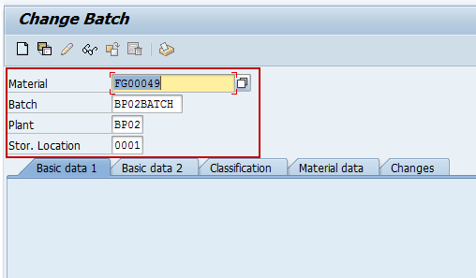

1. Press **Enter** key.
2. On *Change Batch Screen*, tick **Batch Deletion Flag at a Plant** and **Deletion Flag Batch Stock**.

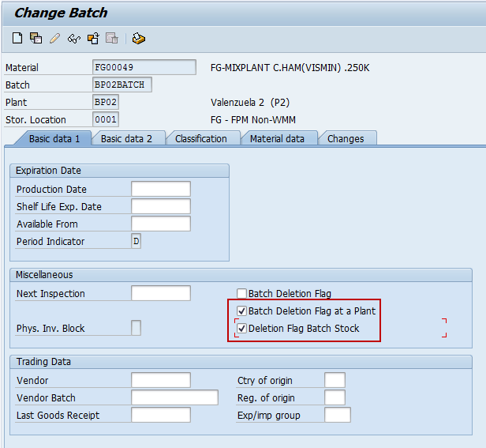

tip**Batch Deletion Flag at a Plant** indicator that flags for deletion all the data on a batch at plant level. The reorganization program checks whether deletion is allowed. If it is the batch data in this plant and all subordinate storage locations is deleted.

tip**Deletion Flag Batch Stock** indicator the flags for deletion all data on a batch at storage location level. The reorganization program checks whether deletion is allowed and, if it is, deletes the data.

1. Click *Save*  icon to save the change/delete batch.

**Result**

Batch for the material has been change/delete.



tip To view the change/delete batch.

1. To view the change/delete batch access the transaction using following navigation options:

|  |  |
| --- | --- |
| **SAP ECC Menu** | Logistics → Materials Management → Material Master → Other → Stock Overview |
| **Transaction code** | MMBE |

1. On *Stock Overview: Company Code/Plant/Storage Location/Batch Screen,* make the following entries:

|  |  |  |
| --- | --- | --- |
| **Field Name** | **User action and values** | **Comment** |
| Material | Required | Alphanumeric key uniquely identifying the [material](SAPEVENT:DOCU_LINK\DS:GLOS.material) |
| Plant | Required | Key uniquely identifying a [plant](SAPEVENT:DOCU_LINK\DS:GLOS.plant). |
| Stor. Location | Required | Number of the [storage location](SAPEVENT:DOCU_LINK\GL:storage_location) at which the material is stored. A [plant](SAPEVENT:DOCU_LINK\GL:plant) may contain one or more storage locations. |
| Batch | Required | Assigns a [material](SAPEVENT:DOCU_LINK\DS:GLOS.3526BEB5AFAB52B9E10000009B38F974) that is manufactured in batches or production lots to a specific [batch](SAPEVENT:DOCU_LINK\DS:GLOS.3526BFBFAFAB52B9E10000009B38F974). |

1. Click *Execute*  icon or press F8.
2. On *Stock Overview:Basic List Screen*, notice that your created batch has mark **X** in **Del. Flag**.

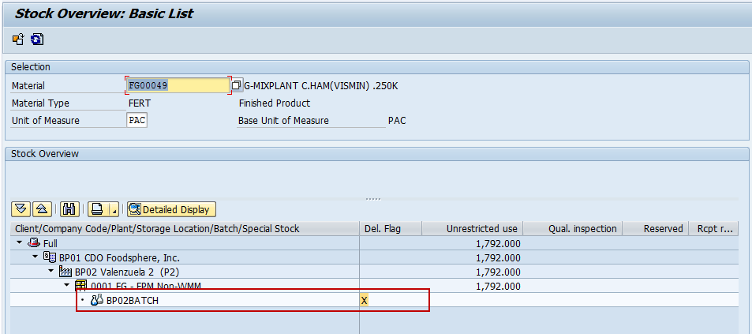

tip**Del. Flag** is the general deletion flag.