Breakthrough Methodology
Business Process Procedure

Material Reservation

Breakthrough Methodology
July 2009
English
Project: CDO Foodsphere Inc.
Prepared By: Michael Mendoza Mella, CpE
SAP MM/WM Specialist
Sr. SAP ABAP Developer

Strictly Confidential

Icons

Icon | Meaning
 | Caution
 | Example
 | Note
 | Recommendation
 | Syntax

Typographic Conventions

Type Style | Description
Example text | Words or characters that appear on the screen. These include field names, screen titles, pushbuttons as well as menu names, paths and options.  Cross-references to other documentation.
Example text | Emphasized words or phrases in body text, titles of graphics and tables.
EXAMPLE TEXT | Names of elements in the system. These include report names, program names, transaction codes, table names, and individual key words of a programming language, when surrounded by body text, for example, SELECT and INCLUDE.
Example text | Screen output. This includes file and directory names and their paths, messages, source code, names of variables and parameters as well as names of installation, upgrade and database tools.
EXAMPLE TEXT | Keys on the keyboard, for example, function keys (such as F2) or the ENTER key.
Example text | Exact user entry. These are words or characters that you enter in the system exactly as they appear in the documentation.
<Example text> | Variable user entry. Pointed brackets indicate that you replace these words and characters with appropriate entries.

Print Material Reservation

Use
This activity is to print material reservation.

Procedure
- Access the transaction using the following navigation options:
SAP ECC Menu | -
Transaction code | ZMM052

- In the Material Reservation Slip Screen, enter the required field “Requirement Date or Reservation Number”. You can also make the following entries:
Field Name | User action and values | Comment
Requirement Date |  | Specifies the date on which the requested quantity of material is required.
Reservation Number |  | Alphanumeric key uniquely identifying the document.
Movement Type
Plant
Cost Center
Goods Recipient
Created By

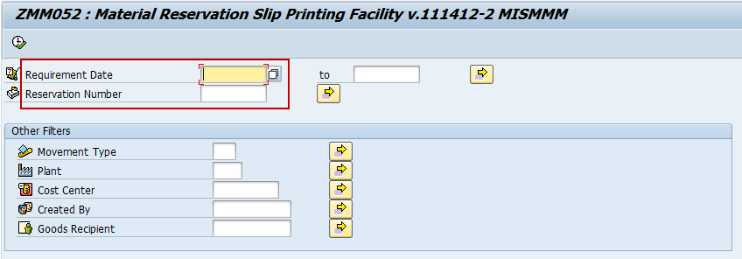

- If you press Enter and the required field is empty, an Error Message will appear.

- If your done entering the Requirement Date or Reservation Number, press Enter.

- Click Execute Icon.

- List of the Material Reservation will be displayed.

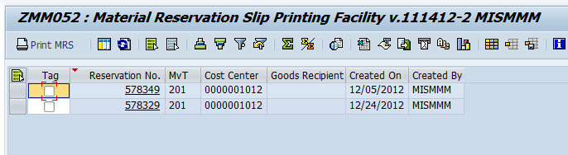

- Click the Material Reservation Number to see the details.

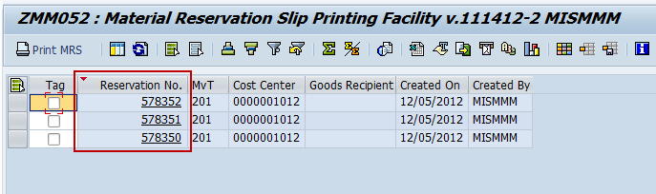

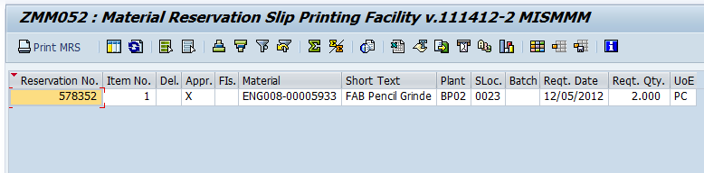

- Choose icon or function F3 to go back.

- Tick the Reservation no. to be printed.

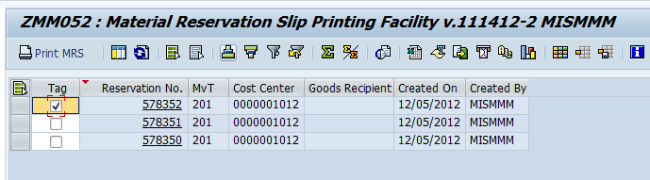

- Click the Print MRS 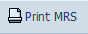 icon.

- In Print Initial Screen, set LOCL as output device and check the Print Immediately.

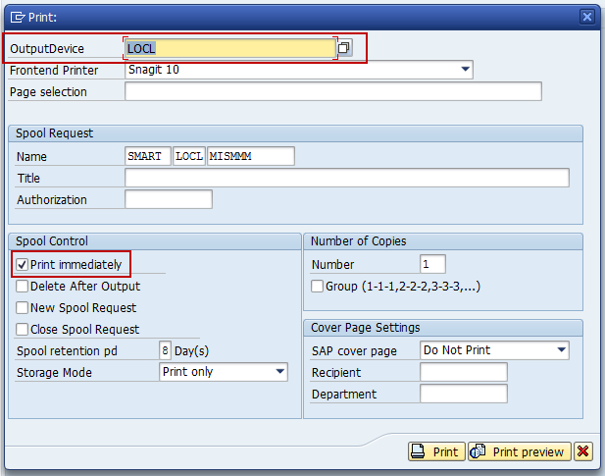

- Click the Print Preview icon, print preview is generated.

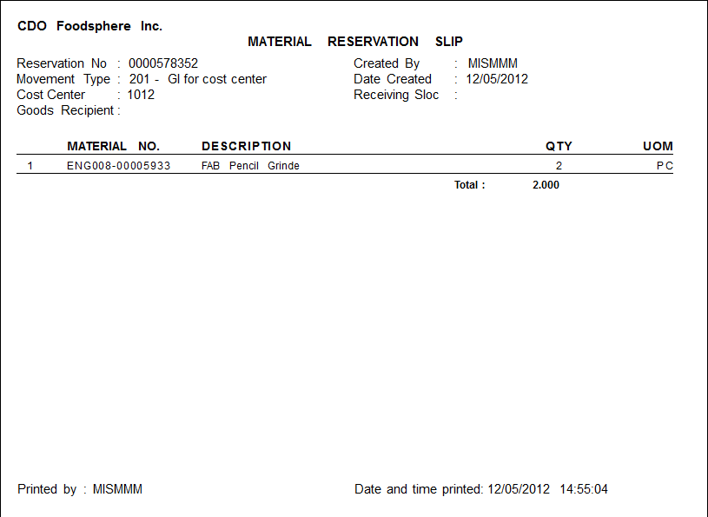

- Click Print icon to print the material reservation slip.

