Breakthrough Methodology
Business Process Procedure

??

Breakthrough Methodology
July 2009
English
Project: CDO Foodsphere Inc.
Prepared By: Michael Mendoza Mella

Strictly Confidential

Icons

Icon | Meaning
 | Caution
 | Example
 | Note
 | Recommendation
 | Syntax

Typographic Conventions

Type Style | Description
Example text | Words or characters that appear on the screen. These include field names, screen titles, pushbuttons as well as menu names, paths and options.  Cross-references to other documentation.
Example text | Emphasized words or phrases in body text, titles of graphics and tables.
EXAMPLE TEXT | Names of elements in the system. These include report names, program names, transaction codes, table names, and individual key words of a programming language, when surrounded by body text, for example, SELECT and INCLUDE.
Example text | Screen output. This includes file and directory names and their paths, messages, source code, names of variables and parameters as well as names of installation, upgrade and database tools.
EXAMPLE TEXT | Keys on the keyboard, for example, function keys (such as F2) or the ENTER key.
Example text | Exact user entry. These are words or characters that you enter in the system exactly as they appear in the documentation.
<Example text> | Variable user entry. Pointed brackets indicate that you replace these words and characters with appropriate entries.

Parking of Released PR

Procedure
- Access the transaction using following navigation option:
Transaction code | ZMM067P

- On the Parking of Released PR Screen, make the following entries:
Field Name | User action and values | Comment
Requisition Date | Required | Specifies the date on which the purchase requisition was created.

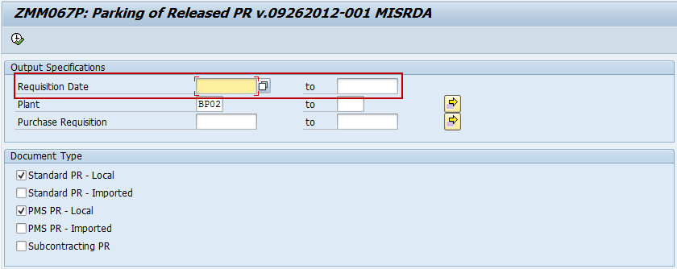

Note:
If the Required fields is null, warning message will appear.

- Click the Execute icon. The system will display the list based on your selection.

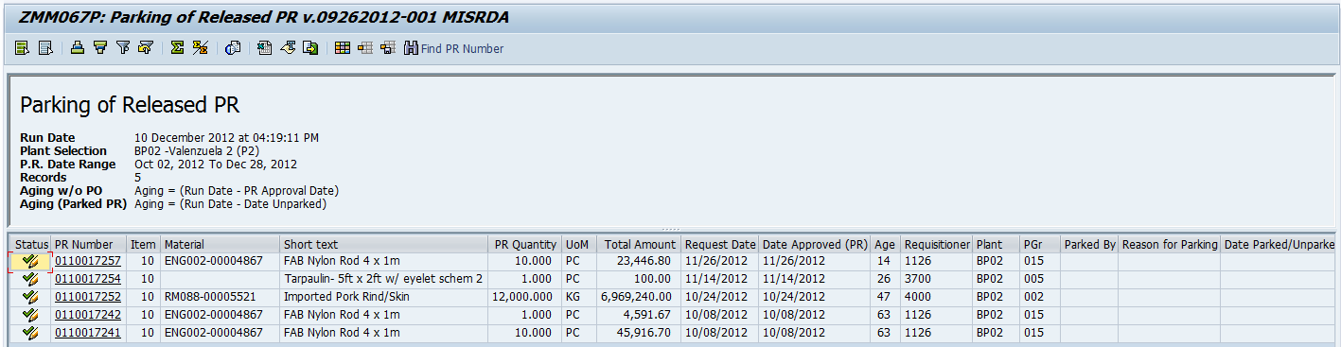

- Click Park icon to park the PR number next to it.

- A dialog box will pop up, input your reason for parking.

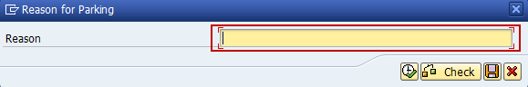

- Click Execute icon or press F8. You will notice that the Park icon change into Unpark icon and other fields are fill up. The Unpark icon means that the PR number next to it has already park.

- Click Unpark icon to unpark the selected purchase requisition number. Notice that Parked marked X, it indicate that it is park before.

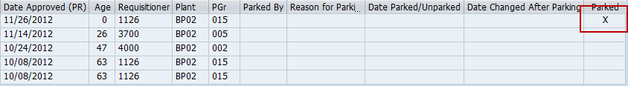

- To export the list as a local file (MS Excel Format), click the Local File icon or press Ctrl + Shift + F9.

- A dialog box will appear, choose the Spreadsheet option.
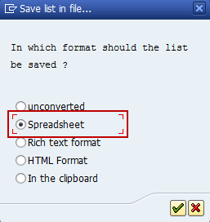

- Click icon or press Enter to continue. The system ask you the directory and filename of the file. Click Generate button.

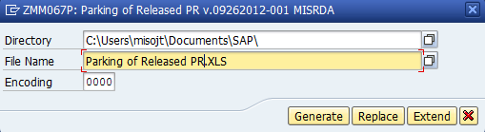

- The list has been exported ti specified directory.

- Click Back button or press F3 to go back to the initial screen.

