|  |
| --- |
| English |
| **Breakthrough Methodology**  **Business Process Procedure** |
|  |
|  |
|  |

Create Physical Inventory Documents (Collective)

|  |  |
| --- | --- |
| Breakthrough Methodology  July March 2001 2009  EnglishEnglish |  |

### 

Project: CDO Foodsphere Inc.

Prepared By: Michael Mendoza Mella, CpE

SAP MM Specialist

Strictly Confidential

#### Icons

|  |  |
| --- | --- |
| Icon | Meaning |
| achtung | Caution |
| example | Example |
| tip | Note |
| recommen | Recommendation |
| syntaxic | Syntax |

#### Typographic Conventions

|  |  |
| --- | --- |
| Type Style | Description |
| Example text | Words or characters that appear on the screen. These include field names, screen titles, pushbuttons as well as menu names, paths and options.  Cross-references to other documentation. |
| Example text | Emphasized words or phrases in body text, titles of graphics and tables. |
| EXAMPLE TEXT | Names of elements in the system. These include report names, program names, transaction codes, table names, and individual key words of a programming language, when surrounded by body text, for example, SELECT and INCLUDE. |
| Example text | Screen output. This includes file and directory names and their paths, messages, source code, names of variables and parameters as well as names of installation, upgrade and database tools. |
| EXAMPLE TEXT | Keys on the keyboard, for example, function keys (such as F2) or the ENTER key. |
| Example text | Exact user entry. These are words or characters that you enter in the system exactly as they appear in the documentation. |
| <Example text> | Variable user entry. Pointed brackets indicate that you replace these words and characters with appropriate entries. |

# 

# 

# Create Physical Inventory Documents (Collective)

**Use**

This activity is performed to create physical inventory documents collectively on per plant - per storage location-per stock type technique. The facility mimics the functionality of SAP standard transaction code **MI01 – Creating Physical Inventory Documents**. The resulting PIDs will be automatically exported into an excel file template that will serve as the count sheets.

**Procedure**

1. Access the transaction using the following navigation option:

|  |  |
| --- | --- |
| **Transaction code** | ZMM060 |

1. On the *Create Phys. Inv. Documents (Collective)* initial screen, make the following entries:

|  |  |  |
| --- | --- | --- |
| **Field Name** | **User action and values** | **Comment** |
| Document Date | Required. | The document date is the date on which the original document was issued. |
| Planned Count Date | Required. | Indicates the date on which the physical inventory count is to take place. |
| **Location of Physical Inventory** |  |  |
| Plant | Required. | Key uniquely identifying a [**plant**](SAPEVENT:DOCU_LINK\DS:GLOS.plant). |
| Storage Location | Required. | Number of the [**storage location**](SAPEVENT:DOCU_LINK\GL:storage_location) at which the material is stored. A [**plant**](SAPEVENT:DOCU_LINK\GL:plant) may contain one or more storage locations. |
| Limit Batch Count to | 300. | Maximum number of line items to be generated after creation PIDs. |
| **Other Information** |  |  |
| Posting Block | Tick Box - Check | Indicates that no [**goods movements**](SAPEVENT:DOCU_LINK\DS:GLOS.3526C107AFAB52B9E10000009B38F974) involving the materials listed in the physical inventory document can be posted for the duration of a [**physical inventory count**](SAPEVENT:DOCU_LINK\DS:GLOS.3526C068AFAB52B9E10000009B38F974). |
| Batches w. del. Flag | Check Box. | Select if you want to include batches with deletion flag indicator. |
| Selected Materials Only | Optional. | Fill this parameter if you want to generate PIDs for a specific material(s) only. |
| **Stock Types** |  |  |
| Unrestricted Use | Option Button. | Indicates that the [**unrestricted-use stock**](SAPEVENT:DOCU_LINK\DS:GLOS.3526C0B8AFAB52B9E10000009B38F974) is affected by the transaction. Select this option to generate PID for this stock type. |
| In Quality Inspection | Option Button. | Indicates that the  [**stock**](SAPEVENT:DOCU_LINK\DS:GLOS.3526C0B8AFAB52B9E10000009B38F974)s in-quality inspection is affected by the transaction. Select this option to generate PID for this stock type. |
| Blocked | Option Button. | Indicates that the [**blocked stock**](SAPEVENT:DOCU_LINK\DS:GLOS.3526C0B8AFAB52B9E10000009B38F974) is affected by the transaction. Select this option to generate PID for this stock type. |

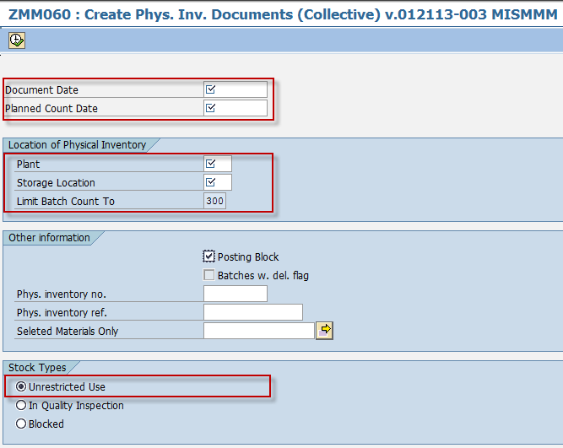

1. Click the *Execute*  button or press F8. The program will attempt to create physical inventory documents for all of the materials maintained in the input storage location of the input plant. The generated PIDs will be then extracted into an excel file templates.



1. A system message will appear informing the user that the excel file templates were succesfully saved. The template file location will be displayed on the next screen after execution.



1. Further details will be displayed like logs summary, number of encounted errors and template file location as well as the date and time of extraction.

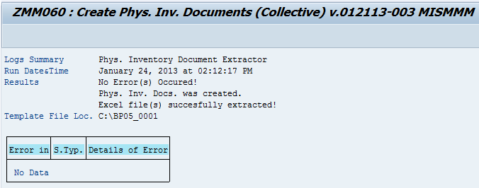

1. Click the *Back* img174 icon to go back on the previous screen.

**Result**

**[**

1. Physical Inventory Documents was generated.
2. Template file (Countsheets) was extracted.

 To create PIDs for the other **Stock Types (In-QI, Blocked),** repeat nos. 1-6 and choose the corresponding stock type option button.

**Enter Physical Inventory Count on the count sheet (Excel Template)**

1. Navigate to the template file location of your extracted templates.

 The filepath of the extracted templates follows the format of :

**C:\Plant**_**StorageLocation**

Ex. C:\ BP0X_0001

 The filename of the extracted templates follows the format of :

**Plant**_**StorageLocation**_**StockType**_**PIDNumber**.

Ex. BP0X_0001_1_100012345

achtung **Please do not change the default filename of the template.**

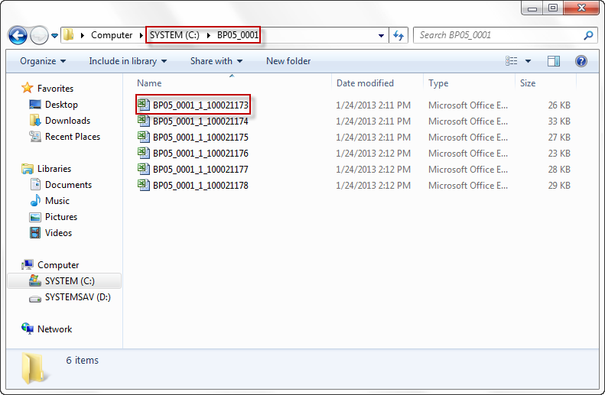

1. Open the excel file template to enter the physical inventory count on the selected PID.

Input the count on the “**Actual Count**” column.

Input the unit of entry on the “**Unit of Entry**” column.

achtung **If you did not specify the unit of entry, the system will then assume and take the default base unit of measure of the material.**

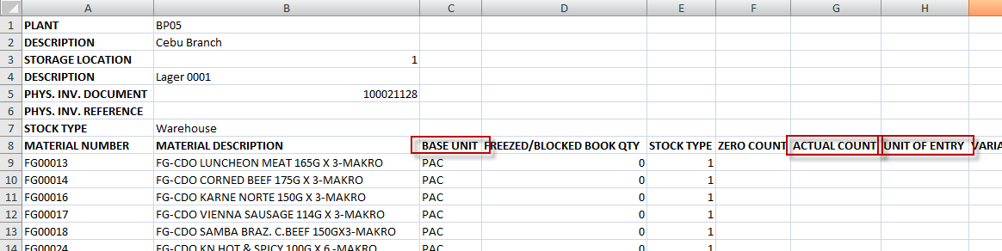

1. Press Ctrl + S to save the file.

**Result**

**[**

1. Actual physical count has been set.
2. You can now proceed to to post the physical inventory document.