|  |
| --- |
| English |
| **Breakthrough Methodology**  **Business Process Procedure** |
|  |
|  |
|  |

Enter Count, Post PID

(Collective)

|  |  |
| --- | --- |
| Breakthrough Methodology  July March 2001 2009  EnglishEnglish |  |

### 

Project: CDO Foodsphere Inc.

Prepared By: Michael Mendoza Mella, CpE

SAP MM Specialist

Strictly Confidential

#### Icons

|  |  |
| --- | --- |
| Icon | Meaning |
| achtung | Caution |
| example | Example |
| tip | Note |
| recommen | Recommendation |
| syntaxic | Syntax |

#### Typographic Conventions

|  |  |
| --- | --- |
| Type Style | Description |
| Example text | Words or characters that appear on the screen. These include field names, screen titles, pushbuttons as well as menu names, paths and options.  Cross-references to other documentation. |
| Example text | Emphasized words or phrases in body text, titles of graphics and tables. |
| EXAMPLE TEXT | Names of elements in the system. These include report names, program names, transaction codes, table names, and individual key words of a programming language, when surrounded by body text, for example, SELECT and INCLUDE. |
| Example text | Screen output. This includes file and directory names and their paths, messages, source code, names of variables and parameters as well as names of installation, upgrade and database tools. |
| EXAMPLE TEXT | Keys on the keyboard, for example, function keys (such as F2) or the ENTER key. |
| Example text | Exact user entry. These are words or characters that you enter in the system exactly as they appear in the documentation. |
| <Example text> | Variable user entry. Pointed brackets indicate that you replace these words and characters with appropriate entries. |

# 

# 

# Enter Count, Post Physical Inventory Documents (Collective)

**Use**

This activity is performed to upload the excel file template of physical inventory documents generated from executing **ZMM061 – Create Physical Inventory Documents (Collective)**. The uploading process will result to mass entering of count and then posting the PIDs onto the SAP system. The facility mimics the functionality of SAP standard transaction code **MI04 – Enter Physical Inventory Count** and **MI07 – Post Physical Inventory Count**.

**Procedure**

1. Access the transaction using the following navigation option:

|  |  |
| --- | --- |
| **Transaction code** | ZMM061 |

1. On the *Set Count, Post PID (Collective)* initial screen, make the following entries:

|  |  |  |
| --- | --- | --- |
| **Field Name** | **User action and values** | **Comment** |
| **Upload Excel File Template** |  |  |
| Choose file | Required. Select from the pop up dialog box. | Path of the excel file template you wish to upload for enter count and posting. Please make sure that you did not change the filename of the template before uploading. |

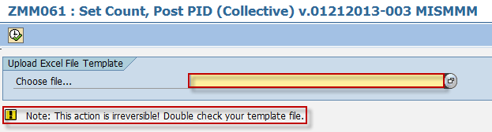

1. The system will perform initial validation on your file upon loading preventing to upload the same file twice and if the file contains invalid data.

Error message if the file is open in another window.



Error message if the file was already uploaded.



System message if the file is valid for uploading.



1. Click *Execute*  button to proceed on uploading the template. A confirmation message will pop up on the screen to verify your action. Click  button to continue. Once you clicked this, this action is irreversible.

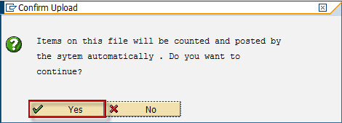

1. The uploader facility will then process your file. It will automatically post the physical inventory document contained in the template by using the count you have provided on the template file. An Information dialog box will appear once the uploader is finished and informing the user that the uploading process was succesfull. The material document number as the product of posting is also displayed in the message information dialog.

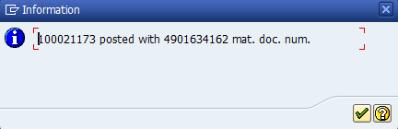

1. Click *Check*  button or press *Enter* to display the physical inventory list output.

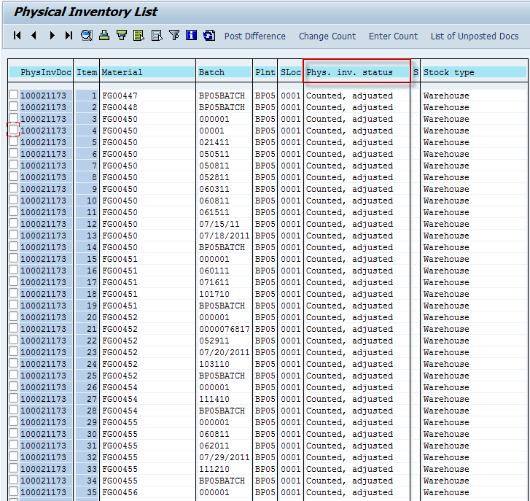

1. Click the Back img174 icon to go back on the previous screen.

 To upload another template, repeat nos. 1 – 6 and select the file accordingly.

**Result**

**[**

1. Physical inventory document was posted.
2. A material document number was generated.
3. Status of PID is counterd, adjusted.