|  |
| --- |
| English |
| **Breakthrough Methodology**  **Business Process Procedure** |
|  |
|  |
|  |

Goods Issue

|  |  |
| --- | --- |
| Breakthrough Methodology  July March 2001 2009  EnglishEnglish |  |

### 

Project: CDO Foodsphere Inc.

Prepared By: Michael Mendoza Mella

Strictly Confidential

#### Icons

|  |  |
| --- | --- |
| Icon | Meaning |
| achtung | Caution |
| example | Example |
| tip | Note |
| recommen | Recommendation |
| syntaxic | Syntax |

#### Typographic Conventions

|  |  |
| --- | --- |
| Type Style | Description |
| Example text | Words or characters that appear on the screen. These include field names, screen titles, pushbuttons as well as menu names, paths and options.  Cross-references to other documentation. |
| **Example text** | Emphasized words or phrases in body text, titles of graphics and tables. |
| EXAMPLE TEXT | Names of elements in the system. These include report names, program names, transaction codes, table names, and individual key words of a programming language, when surrounded by body text, for example, SELECT and INCLUDE. |
| Example text | Screen output. This includes file and directory names and their paths, messages, source code, names of variables and parameters as well as names of installation, upgrade and database tools. |
| EXAMPLE TEXT | Keys on the keyboard, for example, function keys (such as F2) or the ENTER key. |
| Example text | Exact user entry. These are words or characters that you enter in the system exactly as they appear in the documentation. |
| <Example text> | Variable user entry. Pointed brackets indicate that you replace these words and characters with appropriate entries. |

# 

# Goods Issue to a Reservation

## Check Stock Availability

**Use**

This activity is used to check the availability of stocks.

Procedure

1. Access the transaction using the following navigation option:

|  |  |
| --- | --- |
| **SAP menu** | Logistics → Materials Management → Physical Inventory 🡪 Environment 🡪 Stock Overview |
| **Transaction Code** | MMBE |

1. On the *Stock Overview: Company Code/Plant/Storage Location/Batch Screen*, make the following entries:

|  |  |  |
| --- | --- | --- |
| Field name | User action and values | Comment |
| Material |  | Required |
| Plant |  | Optional |
| Storage Location |  | Optional |
| Batch |  | Optional |

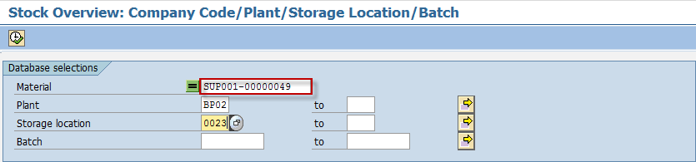

1. Choose *Execute*  button to display.
2. In the *Stock Overview: Basic List* display*,* check on the stock level of the material to be reserved.

tip The column ***Unrestricted Use*** shows the stock available for use.

tip The column ***Qual. Inspection*** shows stock blocked for inspection.

tip The column ***Reserved*** shows stock currently reserved.

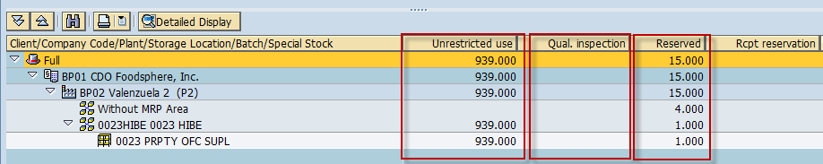

1. If the quantity is sufficient for your requirement, proceed to **Create Reservation - Consumption for Cost Centre from Warehouse.**
2. If quantity is insufficient, add stocks to the material.

# Goods Issue from Warehouse to Department (Cost Center)

**Use**

This activity is performed to issue a material from warehouse to cost center.

Procedure

1. Access the transaction using any of the following navigation options:

|  |  |
| --- | --- |
| **SAP menu** | *Logistics* → *Materials Management* → *Inventory Management*→ *Goods Movement*→ *MIGO* |
| **Transaction code** | MIGO |

1. In the MIGO screen, choose **A07 - Goods Issue** with reference to **R09 - Reservation.**

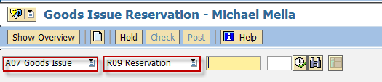

1. Input the Reservation Number or press **F4** to begin a search.
2. Make sure that the **movement type** at the right most part of the screen is **GI for cost center 201**. Otherwise, type **201** in the box.

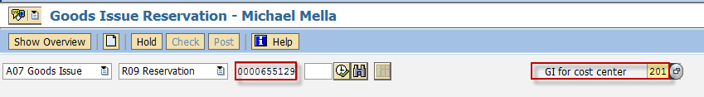

1. Press **Enter.** The details of the Reservation will be copied into the MIGO screen.
2. In the ***Header Data Area***, choose **General** tab and make the following entries as applicable:

| Field name | User action and values | Comment |
| --- | --- | --- |
|  | 3 Collective Slip | Print Active/Inactive |
| Material Slip |  | Required |
| Doc. Header Text |  | Required |

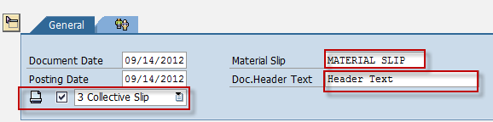

1. In the ***Detail Data Area***, choose **Quantity** tab and make the following entries as applicable:

| Field name | User action and values | Comment |
| --- | --- | --- |
| Qty in Unit of Entry | Numeric value | Quantity to be issued. |

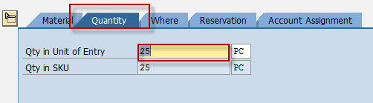

1. In the ***Detail Data Area***,, choose **Where** tab and make the following entries as applicable:

| Field name | User action and values | Comment |
| --- | --- | --- |
| Storage Location | Choose from the dropdown list | Location on where you wish to get the material being issued |
| Goods Recipient | Text value | Input additional name if necessary |
| Text | Text value | Input additional text if necessary |

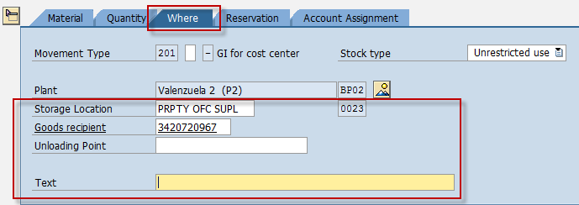

1. In the ***Detail Data Area***,, choose **Reservation** tab and make the following entries as applicable:

| Field name | User action and values | Comment |
| --- | --- | --- |
| Final Issue | Tick Box | Indicate that a reservation item is completed. |

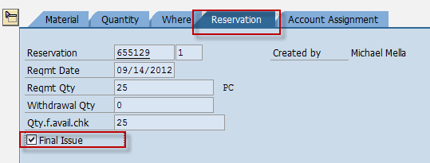

1. Tick the Item OK check box.



1. Click the *Check*  button.
2. A dialog box will appear containing system messages. Confirm all warning messages. Note that an **Error Message** will prevent you from posting the document.
3. Confirm messages by pressing **Enter**.
4. Click Save  icon or Post  button to post the document.

Result

A material document is created for the issuance of goods/items.



# Goods Issue to an Internal Order (Uniforms)

**Use**

This activity is performed to issue a material to an internal order.

Procedure

1. Access the transaction using any of the following navigation options:

|  |  |
| --- | --- |
| **SAP menu** | *Logistics* → *Materials Management* → *Inventory Management*→ *Goods Movement*→ *MIGO* |
| **Transaction code** | MIGO |

1. In the MIGO screen, choose **A07 - Goods Issue** with reference to **R09 - Reservation.**



1. Input the Reservation Number or press **F4** to begin a search.
2. Make sure that the **movement type** at the right most part of the screen is **Advn. To Emp. – Z61**. Otherwise, type **Z61** in the box.

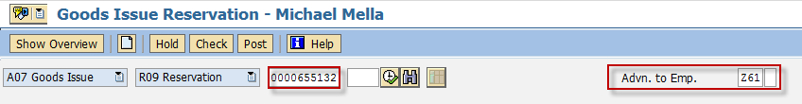

1. Press **Enter.** The details of the Reservation will be copied into the MIGO screen.
2. In the ***Header Data Area***, choose **General** tab and make the following entries as applicable:

| Field name | User action and values | Comment |
| --- | --- | --- |
|  | 3 Collective Slip | Print Active/Inactive |
| Material Slip |  | Required |
| Doc. Header Text |  | Required |



1. In the ***Detail Data Area***, choose **Quantity** tab and make the following entries as applicable:

| Field name | User action and values | Comment |
| --- | --- | --- |
| Qty in Unit of Entry | Numeric value | Quantity to be issued. |



1. In the ***Detail Data Area***,, choose **Where** tab and make the following entries as applicable:

| Field name | User action and values | Comment |
| --- | --- | --- |
| Storage Location | Choose from the dropdown list | Location on where you wish to get the material being issued |
| Goods Recipient | Text value | Input additional name if necessary |
| Text | Text value | Input additional text if necessary |

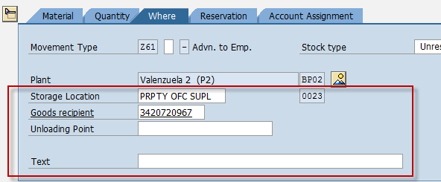

1. In the ***Detail Data Area***,, choose **Reservation** tab and make the following entries as applicable:

| Field name | User action and values | Comment |
| --- | --- | --- |
| Final Issue | Tick Box | Indicate that a reservation item is completed. |



1. Tick the Item OK check box.



1. Click the *Check*  button.
2. A dialog box will appear containing system messages. Confirm all warning messages. Note that an **Error Message** will prevent you from posting the document.
3. Confirm messages by pressing **Enter**.
4. Click Save  icon or Post  button to post the document.

Result

A material document is created for the issuance of goods/items.



# Goods Issue to Assets

**Use**

This activity is performed to issue a material to assets.

Procedure

1. Access the transaction using any of the following navigation options:

|  |  |
| --- | --- |
| **SAP menu** | *Logistics* → *Materials Management* → *Inventory Management*→ *Goods Movement*→ *MIGO* |
| **Transaction code** | MIGO |

1. In the MIGO screen, choose **A07 - Goods Issue** with reference to **R09 - Reservation.**



1. Input the Reservation Number or press **F4** to begin a search.
2. Make sure that the **movement type** at the right most part of the screen is **GI for Asset – 241**. Otherwise, type **241** in the box.

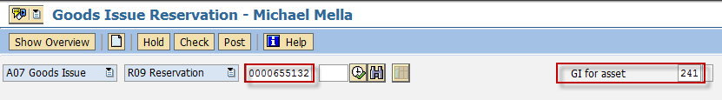

1. Press **Enter.** The details of the Reservation will be copied into the MIGO screen.
2. In the ***Header Data Area***, choose **General** tab and make the following entries as applicable:

| Field name | User action and values | Comment |
| --- | --- | --- |
|  | 3 Collective Slip | Print Active/Inactive |
| Material Slip |  | Required |
| Doc. Header Text |  | Required |



1. In the ***Detail Data Area***, choose **Quantity** tab and make the following entries as applicable:

| Field name | User action and values | Comment |
| --- | --- | --- |
| Qty in Unit of Entry | Numeric value | Quantity to be issued. |



1. In the ***Detail Data Area***,, choose **Where** tab and make the following entries as applicable:

| Field name | User action and values | Comment |
| --- | --- | --- |
| Storage Location | Choose from the dropdown list | Location on where you wish to get the material being issued |
| Goods Recipient | Text value | Input additional name if necessary |
| Text | Text value | Input additional text if necessary |

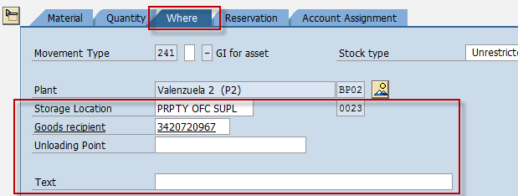

1. In the ***Detail Data Area***,, choose **Reservation** tab and make the following entries as applicable:

| Field name | User action and values | Comment |
| --- | --- | --- |
| Final Issue | Tick Box | Indicate that a reservation item is completed. |



1. Tick the Item OK check box.



1. Click the *Check*  button.
2. A dialog box will appear containing system messages. Confirm all warning messages. Note that an **Error Message** will prevent you from posting the document.
3. Confirm messages by pressing **Enter**.
4. Click Save  icon or Post  button to post the document.

Result

A material document is created for the issuance of goods/items.



# Goods Receipt of Returned Items Issued to Departments

# (GI for Cost Center Reversal)

**Use**

This activity is performed to reverse the effect of GI from warehouse to cost center.

Procedure

1. Access the transaction using any of the following navigation options:

|  |  |
| --- | --- |
| **SAP menu** | *Logistics* → *Materials Management* → *Inventory Management*→ *Goods Movement*→ *MIGO* |
| **Transaction code** | MIGO |

1. In the MIGO screen, choose **A01 - Goods Receipt** with reference to **R09 - Reservation.**

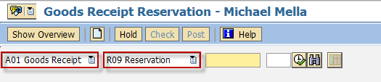

1. Input the Reservation Number or press **F4** to begin a search.
2. Make sure that the **movement type** at the right most part of the screen is **RE for cost center 202**. Otherwise, type **202** in the box.