|  |
| --- |
| English |
| **Breakthrough Methodology**  **Business Process Procedure** |
|  |
|  |
|  |

Goods Receipt

|  |  |
| --- | --- |
| Breakthrough Methodology  July March 2001 2009  EnglishEnglish |  |

### 

Project: CDO Foodsphere Inc.

Prepared By: Michael Mendoza Mella

Strictly Confidential

#### Icons

|  |  |
| --- | --- |
| Icon | Meaning |
| achtung | Caution |
| example | Example |
| tip | Note |
| recommen | Recommendation |
| syntaxic | Syntax |

#### Typographic Conventions

|  |  |
| --- | --- |
| Type Style | Description |
| Example text | Words or characters that appear on the screen. These include field names, screen titles, pushbuttons as well as menu names, paths and options.  Cross-references to other documentation. |
| **Example text** | Emphasized words or phrases in body text, titles of graphics and tables. |
| EXAMPLE TEXT | Names of elements in the system. These include report names, program names, transaction codes, table names, and individual key words of a programming language, when surrounded by body text, for example, SELECT and INCLUDE. |
| Example text | Screen output. This includes file and directory names and their paths, messages, source code, names of variables and parameters as well as names of installation, upgrade and database tools. |
| EXAMPLE TEXT | Keys on the keyboard, for example, function keys (such as F2) or the ENTER key. |
| Example text | Exact user entry. These are words or characters that you enter in the system exactly as they appear in the documentation. |
| <Example text> | Variable user entry. Pointed brackets indicate that you replace these words and characters with appropriate entries. |

# 

# Goods Receipt from Vendor

# Create an Inbound Delivery

**Use**

This activity is performed to create an Inbound Delivery.

Procedure

1. Access the transaction using any of the following navigation options:

|  |  |
| --- | --- |
| **SAP menu** | Logistics Execution → Inbound Process → Goods Receipt for Inbound Delivery  Inbound Delivery → Create → Single Documents |
| **Transaction code** | VL31N |

1. On the *Create Inbound Delivery* Initial Screen, make the following entries then press Enter:

|  |  |  |
| --- | --- | --- |
| **Field Name** | **User action and values** | **Comment** |
| Vendor |  | Required |
| Purchase Order |  | Required |
| **Delivery** |  |  |
| Delivery Date |  | Required |
| External ID | DR# | Required |
| Means of Trans. | Van / Truck Plate # | Required |

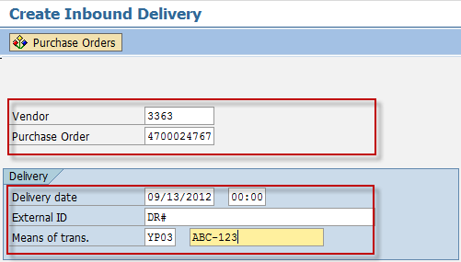

1. On the *Inbound Delivery Create: Overview screen* click the Header Details icon.
2. On the *Inbound Delivery Create: Header Details screen,* go to **Shipment** tab and make the following entries as applicable:

| Field name | User action and values | Comment |
| --- | --- | --- |
| BillOfLad. |  | Waybill |

1. On the *Inbound Delivery Create: Header Details screen,* go to **Text** tab and make the following entries as applicable:

| Field name | User action and values | Comment |
| --- | --- | --- |
| Transport Information |  | Optional |
| Reference Number |  | Optional |
| VQC Number |  | Optional |
| CA Number |  | Optional |
| Padlock |  | Optional |
| Arrival Date |  | Optional |
| Arrival Time In |  | Optional |
| Arrival Time Out |  | Optional |
| Unloading Date |  | Optional |
| Unloading Time In |  | Optional |
| Unloading Time Out |  | Optional |

1. Click the *Save*  icon.

Result

An inbound delivery number is created.



# Goods Receipt against an Inbound Delivery

**Use**

This activity is performed to GR against an Inbound Delivery number.

Procedure

1. Access the transaction using any of the following navigation options:

|  |  |
| --- | --- |
| **SAP menu** | *Logistics* → *Materials Management* → *Inventory Management*→ *Goods Movement*→ *MIGO* |
| **Transaction code** | MIGO |

1. In the MIGO screen, choose **A01 - Goods Receipt** with reference to **R04 - Inbound Delivery.**

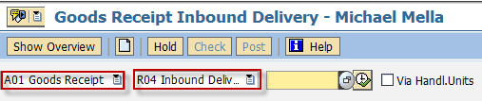

1. Input the Inbound Delivery Number or press **F4** to begin a search.
2. Make sure that the **movement type** at the right most part of the screen is **GR Goods Receipt 101**. Otherwise, type **101** in the box.

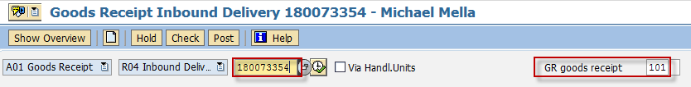

1. Press **Enter.** The details of the Inbound Delivery will be copied into the MIGO screen.
2. In the ***Header Data Area***, choose **General** tab and make the following entries as applicable:

| Field name | User action and values | Comment |
| --- | --- | --- |
|  | 3 Collective Slip | Print Active/Inactive |

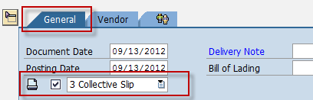

1. In the ***Detail Data Area***, choose **Quantity** tab and make the following entries as applicable:

| Field name | User action and values | Comment |
| --- | --- | --- |
| Qty in Unit of Entry | Numeric value | Change the default quantity if partial delivery. |

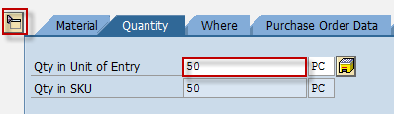

1. In the ***Detail Data Area***,, choose **Where** tab and make the following entries as applicable:

| Field name | User action and values | Comment |
| --- | --- | --- |
| Storage Location | Choose from the dropdown list | Location on where you wish to store the material being received |
| Goods Recipient | Text value | Input additional name if necessary |
| Text | Text value | Input additional text if necessary |

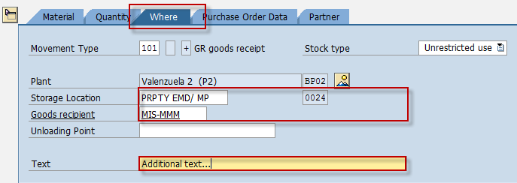

1. In the ***Detail Data Area***,, choose **Purchase Order Data** tab and make the following entries as applicable:

| Field name | User action and values | Comment |
| --- | --- | --- |
| Del. Completed Ind. | List Box | Choose **2 – Set**  Ifthere is no more expected delivery for this purchase order, that is, the PO is already closed. |

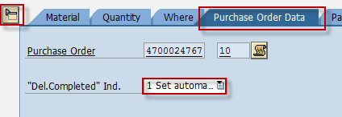

1. Tick the Item OK check box.



1. Click the *Check*  button.
2. A dialog box will appear containing system messages. Confirm all warning messages. Note that an **Error Message** will prevent you from posting the document.
3. Confirm messages by pressing **Enter**.
4. Click Save  icon or Post  button to post the document.

Result

1. A material document is created.
2. The purchase order history tab of the PO is updated.
   1. Access the transaction using any of the following navigation options:

|  |  |
| --- | --- |
| **SAP menu** | *Logistics* → *Materials Management* → *Purchasing* → *Purchase Order → Display* |
| **Transaction code** | ME23N |

* 1. In the Standard PO screen, choose  icon.
  2. In the *Select Document dialog box,* enter the PO number,
  3. Press Enter.
  4. The Purchase Order is displayed. Notice a new tab added to the Purchase Order: **Purchase Order History**. The tab is updated by the goods receipt done.

# Print Goods Receipt Slip

**Use**

This activity is performed to print GR Slip.

Procedure

1. Access the transaction using any of the following navigation options:

|  |  |
| --- | --- |
| **SAP menu** | *Logistics* → *Materials Management* → *Inventory Management*→ *Material Document 🡪 Process Output* |
| **Transaction code** | MB90 |

1. In the *Output from Goods Movement Screen,* make the following entries:

| Field name | User action and values | Comment |
| --- | --- | --- |
| Processing Mode | Choose from dropdown list.  **0** – Initial processing  **1** – Repeat processing |  |
| Material Document | Choose from dropdown list. | Use the material document number generated in the preceding section. |

1. Click Execute  button.

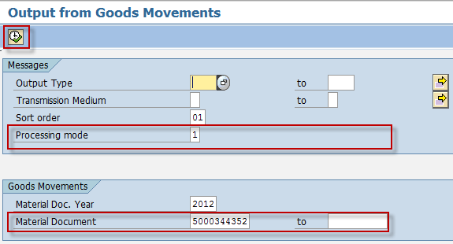

1. In the succeeding screen, tick the check box before the material document field then click *Execute*  button.

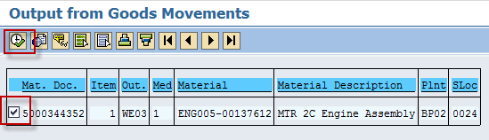

1. Click *Preview*  icon. A print preview is generated.

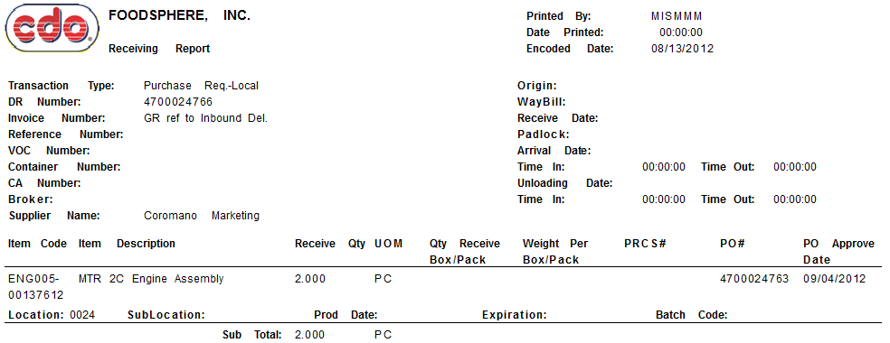

1. Click the Print icon to print the GR Slip.

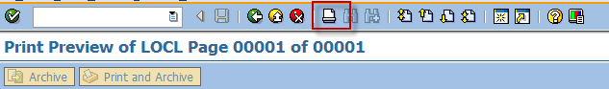

Result

A spool request has been sent to the printer.