Breakthrough Methodology

Business Process Procedure

Material Master
– HIBE (Operating Supplies) /
ERSA (Spare Parts)
Project: CDO Foodsphere Inc.
Prepared By: Michael Mendoza Mella

Strictly Confidential

Icons

Icon | Meaning
 | Caution
 | Example
 | Note
 | Recommendation
 | Syntax

Typographic Conventions

Type Style | Description
Example text | Words or characters that appear on the screen. These include field names, screen titles, pushbuttons as well as menu names, paths and options.  Cross-references to other documentation.
Example text | Emphasized words or phrases in body text, titles of graphics and tables.
EXAMPLE TEXT | Names of elements in the system. These include report names, program names, transaction codes, table names, and individual key words of a programming language, when surrounded by body text, for example, SELECT and INCLUDE.
Example text | Screen output. This includes file and directory names and their paths, messages, source code, names of variables and parameters as well as names of installation, upgrade and database tools.
EXAMPLE TEXT | Keys on the keyboard, for example, function keys (such as F2) or the ENTER key.
Example text | Exact user entry. These are words or characters that you enter in the system exactly as they appear in the documentation.
<Example text> | Variable user entry. Pointed brackets indicate that you replace these words and characters with appropriate entries.

Contents

Create Operating Supplies (HIBE) or Spare Parts (ERSA) Material 4
Basic Data 6
Purchasing Data 6
General/Storage Data 6
Accounting Data 7
Appendix 8
Reversal of Process Steps 8
Extension of Material 8

Create Operating Supplies (HIBE) or Spare Parts (ERSA) Material

Use
This activity is used to create an operating supply or spare part in the Material Master.

Procedure
- Access the transaction using the following navigation option:
SAP menu | Logistics → Materials Management → Material Master → Material → Create (General) → Immediately
Transaction Code | MM01
- On the Create Material: Initial Screen, make the following entries:
Field Name | User action and values | Comment
Material |  | Material Number  (will be internally assigned if field is left blank)
Industry Sector | F Manufacturing - Food | Choose from the dropdown list.
Material Type | HIBE - Operating Supplies  ERSA - Spare Parts | Choose from the dropdown list.
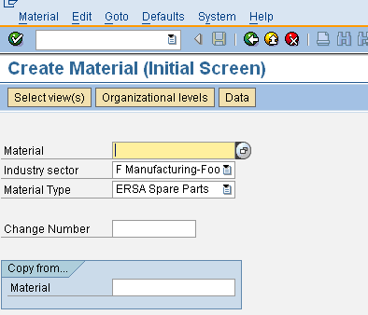
- Press Enter key.
- A Select View(s) dialog box appears. Choose Basic Data 1, Purchasing, General Plant Data/Storage 1, and Accounting. Choose icon or press Enter.
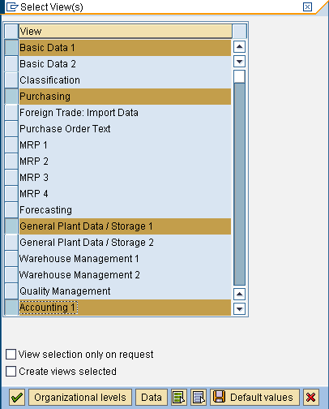
- A dialog box of Organization Levels appears. Make the following entries:
Field Name | User action and values | Comment
Plant | Choose from the dropdown list. | Plant on which you wish to create or extend the material
Stor. Location | Choose from the dropdown list. | Location on which you wish to store the maaterial
- Click icon or press Enter.
Materials are first created in the primary procurement/production plant.
To view the material lists, run the transaction MM60 or use the menu path Logistics  Materials Management  Material Master  Other  Materials List.
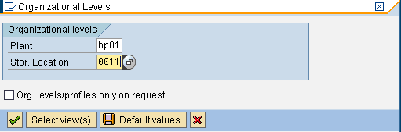

Basic Data

- On the Basic Data 1 tab, enter the following values and choose Enter:
Field name | User action and values | Comment
Description | <enter description>
Base Unit of Measure | <enter Base Unit of measure> | Choose from dropdown list.
Material Group |  | Choose from dropdown list.
Old material number | <enter the legacy material number if known>
Gross weight | <enter gross weight>
Weight unit | <enter weight unit>
Net weight | <enter net weight>
- Choose Enter.
- On the Basic Data 2 tab, choose Enter.

Purchasing Data

- On the Purchasing tab, enter the following values and choose Enter:
Field name | User action and values | Comment
Purchasing group |  | Choose from dropdown list.
Purchasing Value Key |  | Choose from dropdown list.
GR Processing Time |  | Enter number of days.
- On the purchase order text screen, enter text that should appear on purchasing documents for this material.

General/Storage Data

- Choose the Plant data/stor.1 tab.
- Enter the following values:
Field name | User action and values | Comment
Period Ind. For SLED | D (days) | Only required if material is subject to batch management with the expiration date search strategy
Min. Rem. Shelf Life | Enter the minimum remaining shelf life | Only required if material is subject to batch management with the expiration date search strategy
Total shelf life | Enter the total shelf life | Only required if material is subject to batch management with the expiration date search strategy
- Choose Enter.
- Choose the Plant data/stor. 2 tab, and choose Enter.

Accounting Data

- On the Accounting 1 tab, make the following entries and choose Enter.
Field name | User action and values | Comment
Price unit | <enter quantity basis>
Price control | V
Standard price
Valuation Class |  | Choose from dropdown list.
- Choose the Accounting 2 tab, and choose Enter.

Result
The operating supply or spare part is created.

Reversal of Process Steps
In the following section, you can find the most common reversal steps that you can take to reverse some of the activities described in this document.

Material Master – Flag for Deletion
Transaction code ( SAP GUI) | MM06
Transaction code ( SAP GUI) | MM06
Comment | In transaction MM06 choose: Material → flag for deletion  Material master deletion requires data archiving (not part of the process scenarios), starting with flagging the material for deletion
- Make the following entries and choose Enter.
Field name | User action and values | Comment
Material | Material number | Material to be deleted
Plant | Plant number | Relating plant
Stor. location | Storage location | Relating storage location, if needed
Warehouse no. | Warehouse Number | If needed
- The Flag for Deletion: Data screen dialog box displays. Select the material number s for deletion as listed.
- Choose Save.

Result
The material is selected for deletion.

Extension of Material

Use
In the following section, a general process of material extension is presented, regardless of material type.

Procedure
- Access the transaction using the following navigation option:
SAP menu | Logistics → Materials Management → Material Master → Material → Create (General) → Immediately
Transaction Code | MM01

- In the Create Material (Initial screen), make the following entries:
Field name | User action and values | Comment
Material | Material number
Copy from.. Material | Material number | Material to be copied.

- Choose Enter.
- A message “Material Type XXX and Industry Manufacturing-Food copied from master record” appears in the status bar.
- Confirm message by choosing Enter.
- Select View dialog box appears. Choose to select all views then choose Enter.
- In the Organizational Levels dialog box, make the following entries as necessary. Enter selection only to those you require the material to be extended.
Field name | User action and values | Comment
Plant |  | Plant where material will be extended.
Stor Location |  | Storage Location where material will be extended.
Distribution Channel |  | Distribution Channel where material will be extended. Applicable to materials with Sales View.
Warehouse No. |  | Warehouse Number where material will be extended. Applicable to materials with WMS.
- Choose Enter.
- A message “The material already exists and will be extended” appears in the status bar.
- Click Enter several times. Supply missing information as required.
- Choose Save.

Result
The material has been extended.

