|  |
| --- |
| English |
| **Breakthrough Methodology**  **Business Process Procedure** |
|  |
|  |
|  |

Material Reservation

|  |  |
| --- | --- |
| Breakthrough Methodology  July March 2001 2009  EnglishEnglish |  |

### 

Project: CDO Foodsphere Inc.

Prepared By: Michael Mendoza Mella, CpE

SAP MM/WM Specialist

Sr. SAP ABAP Developer

Strictly Confidential

#### Icons

|  |  |
| --- | --- |
| Icon | Meaning |
| achtung | Caution |
| example | Example |
| tip | Note |
| recommen | Recommendation |
| syntaxic | Syntax |

#### Typographic Conventions

|  |  |
| --- | --- |
| Type Style | Description |
| Example text | Words or characters that appear on the screen. These include field names, screen titles, pushbuttons as well as menu names, paths and options.  Cross-references to other documentation. |
| **Example text** | Emphasized words or phrases in body text, titles of graphics and tables. |
| EXAMPLE TEXT | Names of elements in the system. These include report names, program names, transaction codes, table names, and individual key words of a programming language, when surrounded by body text, for example, SELECT and INCLUDE. |
| Example text | Screen output. This includes file and directory names and their paths, messages, source code, names of variables and parameters as well as names of installation, upgrade and database tools. |
| EXAMPLE TEXT | Keys on the keyboard, for example, function keys (such as F2) or the ENTER key. |
| Example text | Exact user entry. These are words or characters that you enter in the system exactly as they appear in the documentation. |
| <Example text> | Variable user entry. Pointed brackets indicate that you replace these words and characters with appropriate entries. |

# 

Contents

Creating a Reservation – Goods Issue for Cost Center 5

Creating a Reservation – Internal Order e.g. Uniforms 8

Creating a Reservation – Goods Issue for Assets 11

Creating a Reservation – Internal Order with Material-to-Material Transfer Posting 14

Approving a Reservation 18

Changing a Reservation 19

Displaying a Reservation 21

Export the Reservations List 22

Generate List of Reservation Slips 23

Print Material Reservation Slips 24

# Creating a Reservation – Goods Issue for Cost Center

**Use**

This activity is performed to create a reservation for GI for Cost Center.

Procedure

1. Access the transaction using any of the following navigation options:

|  |  |
| --- | --- |
| **SAP menu** | Logistics → Materials Management → Inventory Management 🡪 Reservation 🡪 Create |
| **Transaction code** | MB21 |

1. On the *Create Reservation* Initial Screen, make the following entries:

|  |  |  |
| --- | --- | --- |
| **Field Name** | **User action and values** | **Comment** |
| Base Date | Current Date | Specifies the date for which the goods movement is planned |
| Movement Type | **201 –** GI for Cost Center | Enter the code of the required movement type or choose a movement type from the list of [possible entries](SAPEVENT:DOCU_LINK\DS:GLOS.3526B36DAFAB52B9E10000009B38F974). |
| Plant | Choose from the dropdown list | Code of the plant that will receive or issue the goods. |
| **Reference** |  |  |
| Reservation |  | If you enter the number of an already existing reservation, certain data from that document will appear as default values in the reservation that is to be created. |

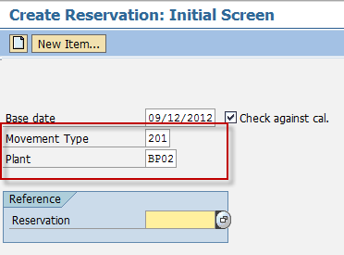

1. Press ***Enter*** key.
2. In the *Create Reservation: New Items screen* make the following entries:

|  |  |  |
| --- | --- | --- |
| **Field Name** | **User action and values** | **Comment** |
| Cost Center |  | Cost Center |
| Goods Recipient |  | Specifies the recipient for whom the material is destined. |
| **Items** |  |  |
| Material | Choose from the dropdown list | Code of the material that you want to reserve. |
| Quantity | Numeric value | Enter the quantity to be moved in any unit of measure for the material. |
| Sloc | Choose from the dropdown list | [Storage location](SAPEVENT:DOCU_LINK\GL:storage_location) at which the material is stored. |
| Batch | Choose from the dropdown list | Batch or valuation type of the material that is to be ordered. |
| M | Tick Box - Uncheck | If you want to prevent a goods movement in respect of this reservation item, you must deselect the field.  If you want to allow a goods movement in respect of this reservation item, select the field. |

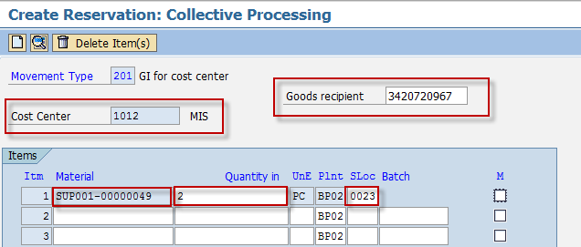

1. Click the *Enter* key*.* The screen moves to *Create Reservation: Details screen.* Otherwise, click the choose  icon.
2. In the *Create Reservation: Details screen,* make the following entries*:*

|  |  |  |
| --- | --- | --- |
| **Field Name** | **User action and values** | **Comment** |
| Requirement Date | Date value | Specifies the date on which the requested quantity of material is required. |
| Text |  | Contains an explanatory text on the line item. |

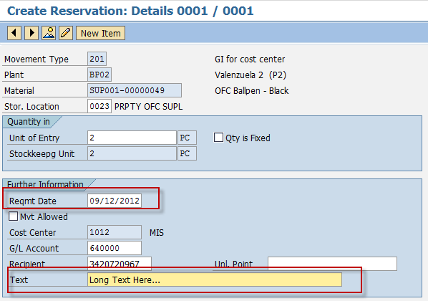

1. Click the Save  icon to save the reservation.

Result

Reservation for the material has been created.



# Creating a Reservation – Internal Order e.g. Uniforms

**Use**

This activity is performed to create a reservation of uniforms.

Procedure

1. Access the transaction using any of the following navigation options:

|  |  |
| --- | --- |
| **SAP menu** | Logistics → Materials Management → Inventory Management 🡪 Reservation 🡪 Create |
| **Transaction code** | MB21 |

1. On the *Create Reservation* Initial Screen, make the following entries:

|  |  |  |
| --- | --- | --- |
| **Field Name** | **User action and values** | **Comment** |
| Base Date | Current Date | Specifies the date for which the goods movement is planned |
| Movement Type | **261 –** Order from Warehouse | Enter the code of the required movement type or choose a movement type from the list of [possible entries](SAPEVENT:DOCU_LINK\DS:GLOS.3526B36DAFAB52B9E10000009B38F974). |
| Plant | Choose from the dropdown list | Code of the plant that will receive or issue the goods. |
| **Reference** |  |  |
| Reservation |  | If you enter the number of an already existing reservation, certain data from that document will appear as default values in the reservation that is to be created. |

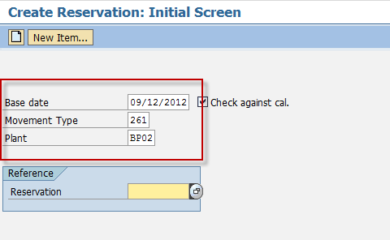

1. Press ***Enter*** key.
2. In the *Create Reservation: New Items screen* make the following entries:

|  |  |  |
| --- | --- | --- |
| **Field Name** | **User action and values** | **Comment** |
| Order |  | Order number which identifies an [order](SAPEVENT:DOCU_LINK\GL:order) within a [client](SAPEVENT:DOCU_LINK\GL:client). |
| Goods Recipient |  | Specifies the recipient for whom the material is destined. |
| **Items** |  |  |
| Material | Choose from the dropdown list | Code of the material that you want to reserve. |
| Quantity | Numeric value | Enter the quantity to be moved in any unit of measure for the material. |
| Sloc | Choose from the dropdown list | [Storage location](SAPEVENT:DOCU_LINK\GL:storage_location) at which the material is stored. |
| Batch | Choose from the dropdown list | Batch or valuation type of the material that is to be ordered. |
| M | Tick Box | If you want to prevent a goods movement in respect of this reservation item, you must deselect the field.  If you want to allow a goods movement in respect of this reservation item, select the field. |

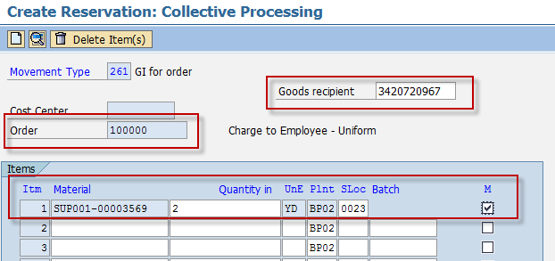

1. Click *Enter* key*.* The screen moves to *Create Reservation: Details screen.* Otherwise, click the choose  icon.
2. In the *Create Reservation: Details screen,* make the following entries*:*

|  |  |  |
| --- | --- | --- |
| **Field Name** | **User action and values** | **Comment** |
| Requirement Date | Date value | Specifies the date on which the requested quantity of material is required. |
| Text |  | Contains an explanatory text on the line item. |

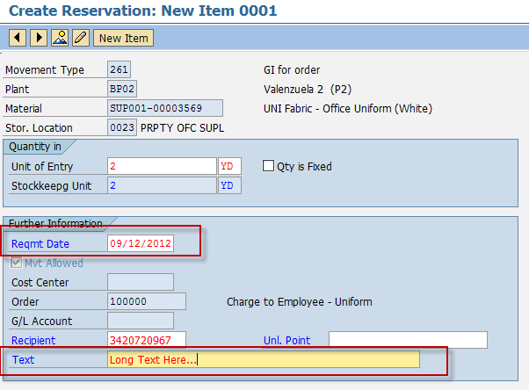

1. Click the Save  icon to save the reservation.

Result

Reservation for the material has been created.



# Creating a Reservation – Goods Issue for Assets

**Use**

This activity is performed to create a reservation for GI for Assets.

Procedure

1. Access the transaction using any of the following navigation options:

|  |  |
| --- | --- |
| **SAP menu** | Logistics → Materials Management → Inventory Management 🡪 Reservation 🡪 Create |
| **Transaction code** | MB21 |

1. On the *Create Reservation* Initial Screen, make the following entries:

|  |  |  |
| --- | --- | --- |
| **Field Name** | **User action and values** | **Comment** |
| Base Date | Current Date | Specifies the date for which the goods movement is planned |
| Movement Type | **241 –** GI for Asset | Enter the code of the required movement type or choose a movement type from the list of [possible entries](SAPEVENT:DOCU_LINK\DS:GLOS.3526B36DAFAB52B9E10000009B38F974). |
| Plant | Choose from the dropdown list | Code of the plant that will receive or issue the goods. |
| **Reference** |  |  |
| Reservation |  | If you enter the number of an already existing reservation, certain data from that document will appear as default values in the reservation that is to be created. |

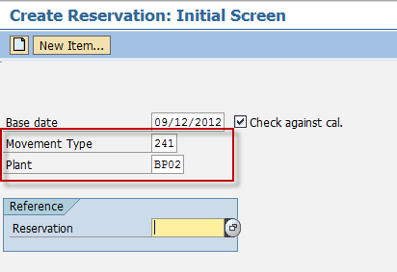

1. Press ***Enter*** key.
2. In the *Create Reservation: New Items screen* make the following entries:

|  |  |  |
| --- | --- | --- |
| **Field Name** | **User action and values** | **Comment** |
| Asset | Required | Number identifying (together with the (asset) sub-number) an [asset](SAPEVENT:DOCU_LINK\DS:GLOS.Asset) in Asset Accounting. |
| Goods Recipient |  | Specifies the recipient for whom the material is destined. |
| **Items** |  |  |
| Material | Choose from the dropdown list | Code of the material that you want to reserve. |
| Quantity | Numeric value | Enter the quantity to be moved in any unit of measure for the material. |
| Sloc | Choose from the dropdown list | [Storage location](SAPEVENT:DOCU_LINK\GL:storage_location) at which the material is stored. |
| Batch | Choose from the dropdown list | Batch or valuation type of the material that is to be ordered. |
| M | Tick Box - Uncheck | If you want to prevent a goods movement in respect of this reservation item, you must deselect the field.  If you want to allow a goods movement in respect of this reservation item, select the field. |

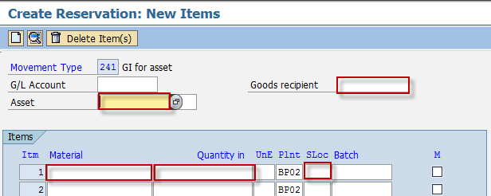

1. Click the *Enter* key*.* The screen moves to *Create Reservation: Details screen.* Otherwise, click the choose  icon.
2. In the *Create Reservation: Details screen,* make the following entries*:*

|  |  |  |
| --- | --- | --- |
| **Field Name** | **User action and values** | **Comment** |
| Requirement Date | Date value | Specifies the date on which the requested quantity of material is required. |
| Text |  | Contains an explanatory text on the line item. |

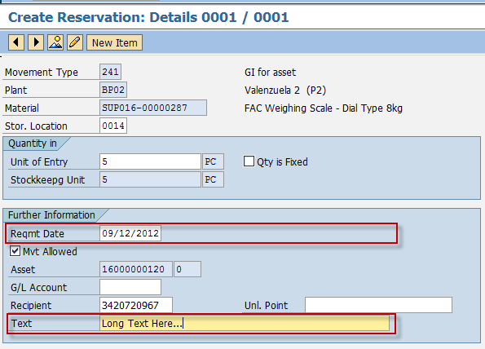

1. Click the Save  icon to save the reservation.

Result

Reservation for the material has been created.



# Creating a Reservation – Internal Order with Material-to-Material Transfer Posting

**Use**

This activity is performed to create a reservation for internal order with transfer posting of material to material.

Procedure

1. Access the transaction using any of the following navigation options:

|  |  |
| --- | --- |
| **SAP menu** | Logistics → Logistic Execution → Internal Whse Processes 🡪 Posting Change 🡪 Via Inventory Management 🡪 Enter Posting Change |
| **Transaction code** | MB1B |

1. On the *Enter Transfer Posting* Initial Screen, make the following entries:

|  |  |  |
| --- | --- | --- |
| **Field Name** | **User action and values** | **Comment** |
| Material Slip |  | Here you can enter an external reference number (for example, the number of a material slip). |
| Doc. Header Text | **Required** | The document header text contains explanations or notes which apply to the [document](SAPEVENT:DOCU_LINK\GL:document) as a whole, that is, not only for certain [line items](SAPEVENT:DOCU_LINK\GL:line_item). |
| Movement Type | **309** – TF material to material | Enter the number of the required movement type or choose a movement type from the list of [possible entries](SAPEVENT:DOCU_LINK\DS:GLOS.3526B36DAFAB52B9E10000009B38F974). |
| Plant |  | Number of the plant that will receive or issue the goods. |

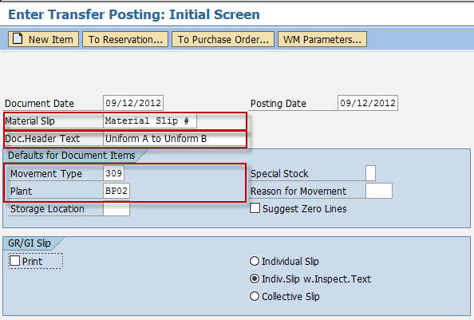

1. Press ***Enter*** key.
2. In the *Enter Transfer Posting: New Items screen* make the following entries:

|  |  |  |
| --- | --- | --- |
| **Field Name** | **User action and values** | **Comment** |
| Rcvg Material | Required | The "receiving material" is the material number under which the quantity to be transferred is now to be recorded. |
| Material | Choose from the dropdown list | Code of the material that you want to transfer. |
| Quantity | Numeric value | Enter the quantity to be moved in any unit of measure for the material. |
| Sloc | Choose from the dropdown list | [Storage location](SAPEVENT:DOCU_LINK\GL:storage_location) at which the material is stored. |

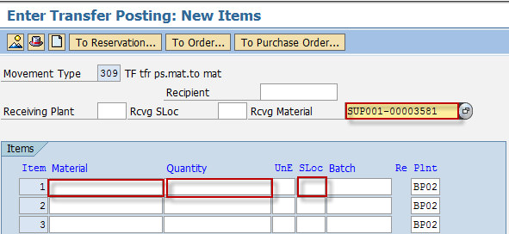

1. Click the *Post*  icon to save the transfer posting process.
2. Access the transaction using any of the following navigation options:

|  |  |
| --- | --- |
| **SAP menu** | Logistics → Materials Management → Inventory Management 🡪 Reservation 🡪 Create |
| **Transaction code** | MB21 |

1. On the *Create Reservation* Initial Screen, make the following entries:

|  |  |  |
| --- | --- | --- |
| **Field Name** | **User action and values** | **Comment** |
| Base Date | Current Date | Specifies the date for which the goods movement is planned |
| Movement Type | **Z61 –** Advance to Employee from warehouse | Enter the code of the required movement type or choose a movement type from the list of [possible entries](SAPEVENT:DOCU_LINK\DS:GLOS.3526B36DAFAB52B9E10000009B38F974). |
| Plant | Choose from the dropdown list | Code of the plant that will receive or issue the goods. |
| **Reference** |  |  |
| Reservation |  | If you enter the number of an already existing reservation, certain data from that document will appear as default values in the reservation that is to be created. |

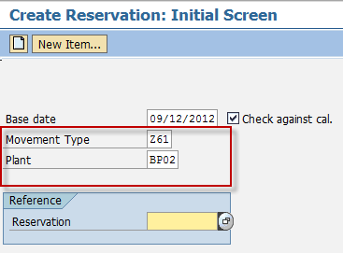

1. Press ***Enter*** key.
2. In the *Create Reservation: New Items screen* make the following entries:

|  |  |  |
| --- | --- | --- |
| **Field Name** | **User action and values** | **Comment** |
| Order | Required | Order number which identifies an [order](SAPEVENT:DOCU_LINK\GL:order) within a [client](SAPEVENT:DOCU_LINK\GL:client). |
| Goods Recipient |  | Specifies the recipient for whom the material is destined. |
| **Items** |  |  |
| Material | Choose from the dropdown list | Code of the material that you want to reserve. |
| Quantity | Numeric value | Enter the quantity to be moved in any unit of measure for the material. |
| Sloc | Choose from the dropdown list | [Storage location](SAPEVENT:DOCU_LINK\GL:storage_location) at which the material is stored. |
| Batch | Choose from the dropdown list | Batch or valuation type of the material that is to be ordered. |
| M | Tick Box - Uncheck | If you want to prevent a goods movement in respect of this reservation item, you must deselect the field.  If you want to allow a goods movement in respect of this reservation item, select the field. |

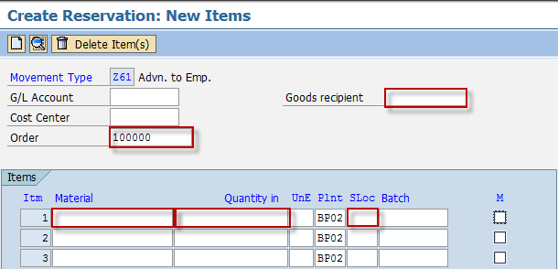

1. Click the *Enter* key*.* A message will indicate the stock availability of the material being reserved.
2. Click the Save  icon to save the reservation.

Result

Reservation for the material has been created.



# Approving a Reservation

**Use**

This activity is performed to approve a reservation.

Procedure

1. Access the transaction using any of the following navigation options:

|  |  |
| --- | --- |
| **SAP menu** | Logistics → Materials Management → Inventory Management 🡪 Reservation 🡪 Change |
| **Transaction code** | MB22 |

1. On the *Change Reservation* Initial Screen, make the following entries:

|  |  |  |
| --- | --- | --- |
| **Field Name** | **User action and values** | **Comment** |
| Reservation |  | Enter the reservation number created in the preceding section to be approved. |

1. Click on the icon  to change the reservation.
2. Tick on the box for *Goods Movement for Reservation Allowed* indicator.

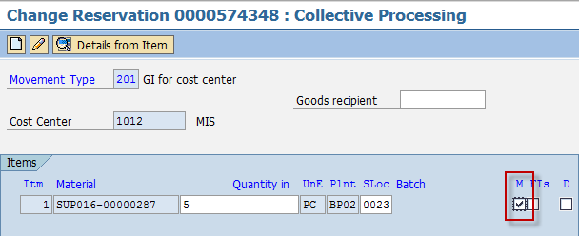

1. Click the *Save*  icon.

Result

Reservation for the material has been approved.



# Changing a Reservation

**Use**

This activity is performed to change or modify an existing reservation.

Procedure

1. Access the transaction using any of the following navigation options:

|  |  |
| --- | --- |
| **SAP menu** | Logistics → Materials Management → Inventory Management 🡪 Reservation 🡪 Change |
| **Transaction code** | MB22 |

1. On the *Change Reservation* Initial Screen, enter the Reservation number or press F4 to begin a search.

|  |  |  |
| --- | --- | --- |
| **Field Name** | **User action and values** | **Comment** |
| Reservation |  | Enter the reservation number created in the preceding section to be approved. |

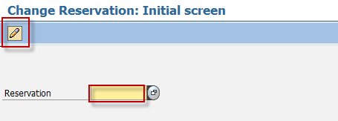

1. Click on the icon  to change the reservation.
2. In the *Change Reservation:* Initial screen*,* change any of the following entries as required:

|  |  |  |
| --- | --- | --- |
| **Field Name** | **User action and values** | **Comment** |
| Quantity | Numeric value | Enter the quantity to be moved in any unit of measure for the material. |
| Sloc | Choose from the dropdown list | [Storage location](SAPEVENT:DOCU_LINK\GL:storage_location) at which the material is stored. |
| FIs | Tick Box | “Final Issue for this Reservation”  The indicator is set automatically for a goods movement when the total reserved quantity has been withdrawn or delivered. In the case of a partial delivery, you can manually set the indicator if no further goods movements are expected in respect of the relevant reservation item. |
| D | Tick Box | “Item is Deleted”  Tick to specify that the item has already been deleted. |

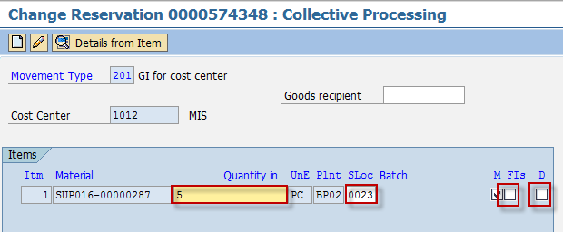

1. Choose  to edit entries per item.
2. In the *Change Reservation XXXX: Details XXXX screen,* change any of the following entries as required:

|  |  |  |
| --- | --- | --- |
| **Field Name** | **User action and values** | **Comment** |
| Requirement Date |  |  |
| Recipient |  |  |
| Text |  |  |

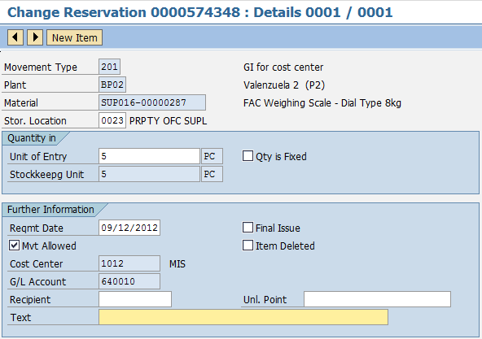

1. Choose  icon to move to next item and change entries as required.
2. Choose  icon to add new items.
3. Click the *Save*  icon to save your changes.

Result

Reservation for the material(s) has been changed.

# Displaying a Reservation

**Use**

This activity is performed to view/display an existing reservation.

Procedure

1. Access the transaction using any of the following navigation options:

|  |  |
| --- | --- |
| **SAP menu** | Logistics → Materials Management → Inventory Management 🡪 Reservation 🡪 Display |
| **Transaction code** | MB23 |

1. In the *Display Reservation:* Initial Screen*,* enter the Reservation number or Press F4 to begin search.

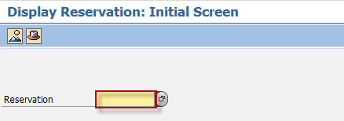

1. Press Enter.

Result

The Reservation is displayed.

# Export the Reservations List

**Use**

This activity is performed to export/print list of reservations.

Procedure

1. Access the transaction using any of the following navigation options:

|  |  |
| --- | --- |
| **SAP menu** | Logistics → Materials Management → Inventory Management 🡪 Reservation 🡪 Display |
| **Transaction code** | MB23 |

1. In the *Display Reservation:* Initial Screen*,* enter the Reservation number or Press F4 to begin search.



1. Press Enter.
2. From the Display a Reservation screen, go to Environment 🡪 Reservation 🡪 For Account Assignment.

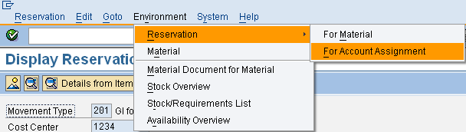

1. Export the resulting list to excel. Go to List 🡪 Export 🡪 Local File.
2. Choose Spreadsheet. Indicate the file name and the directory to which the file will be saved.

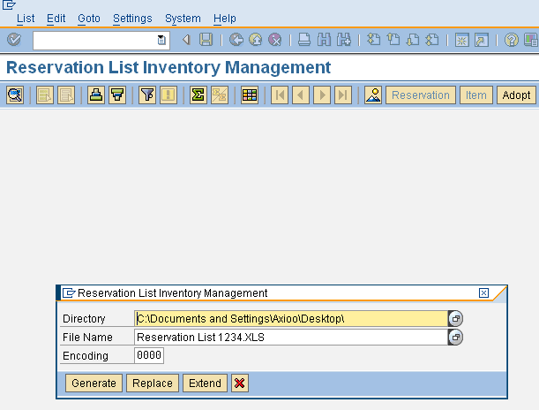

1. Click Generate icon to export the resulting file and distribute as necessary.

Result

Reservation list is exported.

## Generate List of Reservation Slips

Procedure

1. Access the transaction using any of the following navigation options:

|  |  |
| --- | --- |
| **SAP ECC Menu** | *SAP Menu 🡪 Logistics 🡪 Materials Management 🡪 Inventory Management 🡪 Reservation 🡪 Reservation List* |
| **Transaction Code** | MB25 |

1. In the *Reservation List Inventory Management screen,* make the following entries as necessary:

|  |  |  |
| --- | --- | --- |
| **Field Name** | **User action and values** | **Comment** |
| Plant |  |  |
| Requirement Date | Date value |  |
| Goods Recipient |  |  |
| Cost Center |  |  |
| Asset |  |  |
| Open Reservations | Tick or Un-tick as necessary. |  |
| Cancellable Reservations | Tick or Un-tick as necessary. |  |
| Goods Movement Not Possible | Tick or Un-tick as necessary. |  |

1. Click Execute  icon.
2. List of Reservations will be displayed in a grid.

Result

A list of reservations is generated based on your selection parameters.

1. To transport the list to excel for further processing, go to Menu bar List 🡪 Export 🡪 Local File.
2. In the dialog box, choose **Spreadsheet.**
3. Press Enter.
4. Define the Directory to which the file will be saved.
5. Enter the File Name.
6. Choose **Generate.**

Result

The list has been exported to excel.

## Print Material Reservation Slips

Procedure

1. Access the transaction using any of the following navigation options:

|  |  |
| --- | --- |
| **SAP ECC Menu** | *-* |
| **Transaction Code** | ZMM052 |

1. In the *Material Reservation Slip* Initial screen*,* make the following entries as necessary:

|  |  |  |
| --- | --- | --- |
| **Field Name** | **User action and values** | **Comment** |
| Requirement Date | Date value |  |
| Movement Type | Choose from the dropdown list |  |
| Cost Center | Choose from the dropdown list |  |
| Goods Recipient |  |  |
| Created By |  |  |

1. Click Execute  icon.
2. List of Reservations will be displayed in a grid based on your selection parameters.
3. Tick the reservation number to be printed.

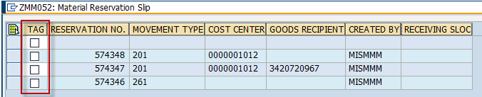

1. Click the print  icon to preview the material slip.
2. Set **LOCL** as output device.
3. Print the slip as necessary.

Result

The reservation has been printed.