DOCUMENT TOPSHEET

HISTORY OF REVISION

DATE | REASON FOR REVISION | AUTHOR
 | First Issue | Michael Mella

Prepared by:

________________________
Mella, Michael M.
SAP MM/WM Specialist, MIS
Signature over Printed Name / Date

Noted by: Approved by:

________________________ ________________________
Encarnacion, Erwina A. Castro, Charmaine O.
Manager, Purchasing VP, Corp. Purchasing and Treasury
Signature over Printed Name / Date Signature over Printed Name / Date

Understood and Accepted by:

_______________________ ________________________
Beth Bersabe Chris Garido
Buyer Buyer
Signature over Printed Name / Date Signature over Printed Name / Date

_______________________ ________________________
Cristine Simangan Edison Dimaliwat
Buyer Buyer
Signature over Printed Name / Date Signature over Printed Name / Date

_______________________ ________________________
Elmer Velasquez Grace Manalang
Buyer Buyer
Signature over Printed Name / Date Signature over Printed Name / Date

_______________________ ________________________
Jericho Tugade Melissa Fernando
Buyer Buyer
Signature over Printed Name / Date Signature over Printed Name / Date

Icons

Icon | Meaning
 | Caution
 | Example
 | Note
 | Recommendation
 | Syntax

Typographic Conventions

Type Style | Description
Example text | Words or characters that appear on the screen. These include field names, screen titles, pushbuttons as well as menu names, paths and options.  Cross-references to other documentation.
Example text | Emphasized words or phrases in body text, titles of graphics and tables.
EXAMPLE TEXT | Names of elements in the system. These include report names, program names, transaction codes, table names, and individual key words of a programming language, when surrounded by body text, for example, SELECT and INCLUDE.
Example text | Screen output. This includes file and directory names and their paths, messages, source code, names of variables and parameters as well as names of installation, upgrade and database tools.
EXAMPLE TEXT | Keys on the keyboard, for example, function keys (such as F2) or the ENTER key.
Example text | Exact user entry. These are words or characters that you enter in the system exactly as they appear in the documentation.
<Example text> | Variable user entry. Pointed brackets indicate that you replace these words and characters with appropriate entries.

Contents
DOCUMENT TOPSHEET 1
Display List of Released Purchase Requisitions 5
Create Request for Quotation 6
Maintain Quotation 9
Price Comparison 10
Create Purchase Order 12
Release Purchase Order 17
Print Purchase Order 19

Appendix A – PO Process Flow Chart

Display List of Released Purchase Requisitions

Use
This activity is performed to display the list of Released Purchase Requisitions.

Procedure
- Access the transaction using the following navigation option:
SAP Graphical User Interface (SAP GUI)
SAP menu | Logistics  Materials Management  Purchasing  Purchase Requisition  List Display  General
Transaction code | ME5A
- On the List Display of Purchase Requisitions : Initial Screen, enter the necessary data:
Field name | User action and values | Remarks
Scope of List | ‘ALV’ | Parameter that determines how the list is edited
Released Requisitions Only | ‘X’ – Check Box | Specifies whether the list display is also to include already-released (approved) purchase requisitions.
Requisns for Overall Release | ‘X’ – Check Box | If you set this indicator, the system lists all purchase requisitions that have to be released (approved) in their entirety.
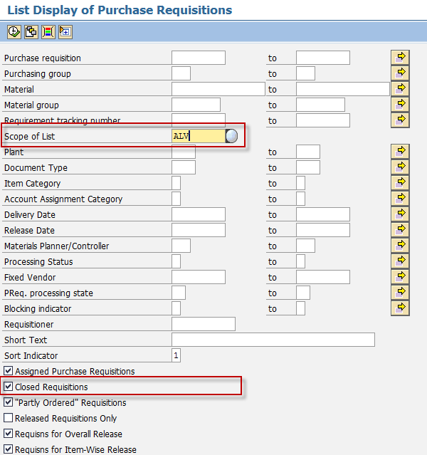
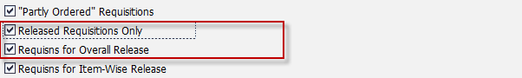
- Click Execute button.
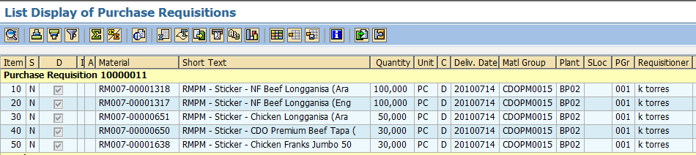
- List of closed Purchase Requisitions will be displayed, choose the necessary Layout to view the desired details of PRs.

Create Request for Quotation

Use
Typical to purchasing, inquiries are sent to possible vendors, who submit an offer/quotation, which is then stored in the system.

Procedure
- Access the transaction using the following navigation option:
SAP Graphical User Interface (SAP GUI)
SAP menu | Logistics  Materials Management  Purchasing  RFQ/Quotation  Request for Quotation  Create
Transaction code | ME41
- On the Create RFQ : Initial Screen, enter the necessary data, and then click Enter:
Field name | User action and values | Remarks
RFQ Type |  | Identifier allowing differentiation between the various kinds of request for quotation (RFQ) in the SAP system.
Language Key | EN | The language key designates the language in which you use
RFQ Date | Date today | Date the request for quotation (RFQ) was created.
Quotation Deadline | Date of deadline | Date by which the vendor is to submit the quotation.
Organizational Data
Purch. Organization |  | Denotes the purchasing organization.
Purchasing Group |  | Key for a buyer or a group of buyers, who is/are responsible for certain purchasing activities.
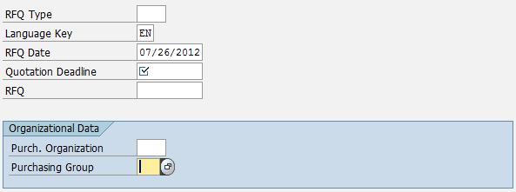

- On the Create RFQ: Item Overview screen, go to RFQ → Create with Reference → To Purchase Req. or
using the shortcut Ctrl + F3.
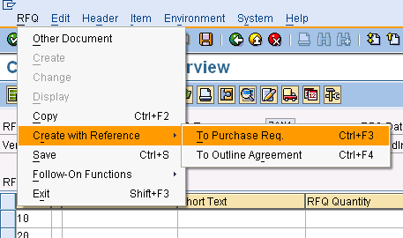

- Key in the Purchase Requisition Number.
- Details will appear based on the referenced Purchase Requisition. Click the leftmost button of the line item to highlight all the details and click the Adopt + Details button.
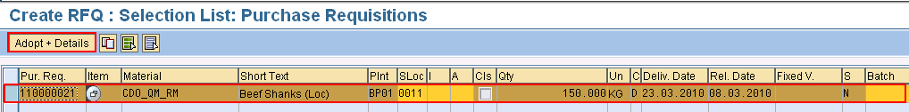

- Click the Header details icon.
- Enter Collective Number (for easier to Monitor), then Click the Vendor Address icon.

To administer several requests for quotations, a tracking number can be assigned to each request. This makes it possible to list and monitor the requests for quotations. Furthermore, the quotations can be compared and further processed according to the tracking number. The following steps create the tracking number.

Field Name | User action and values | Remarks
Administrative Fields Section
Coll. no. |  | Enter a special tracking number

In the next step, you enter the vendors from whom you would like to receive a quotation.

- Enter Vendor code (choose from the drop down list) on the vendor field. Press Enter. The details regarding the Vendor will be adapted. Click the Save Button. The system will generate an RQF reference number. Below will appear RFQ-X created under the number XXXXXXXXXX.

- To add another Vendor, Repeat Step 8.

- If done click the Exit or Shift + F3.

Maintain Quotation

Use
In this section the quotations from the vendors are entered into the system. These quotations reference the request for quotations created in the previous section.

Procedure

- Access the transaction using one of the following navigation options:
SAP menu | Logistics → Materials Management → Purchasing → RFQ/Quotation → Quotation → Maintain
Transaction Code | ME47

- On the Maintain Quotation: Initial screen, input the following entry then press enter.
Field name | User action and values | Remarks
RFQ | Enter your RFQ number | Choose from dropdown list

- On the Maintain Quotation: Item Overview. Click the leftmost button to select the material or line item to be maintained. Click the item details icon. Enter the following fields:
Field name | User action and values | Remarks
Quotation Data Section
Net Price |  | Enter the Price given by the suppliers
Tax Code |  | Optional
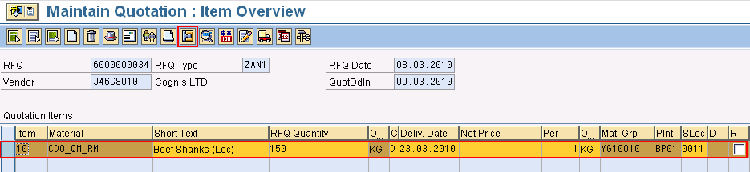
- Choose Save icon. Below a message will appear - ‘Quotation for RFQ-XXX XXXXXXXXX Maintained’.
- Maintain the next Quotation by using the same procedure with the previous transaction.

Price Comparison

Use
You can compare the prices among the quotations received as a result of a competitive bidding process using the price comparison list. The comparison list ranks the quotations by item from lowest to highest price.

Procedure
- Access the transaction using one of the following navigation options:
SAP menu | Logistics → Materials Management → Purchasing → RFQ/Quotation → Quotation → Price Comparison
Transaction Code | ME49
- On the Price Comparison List screen, enter the following fields and press the Execute icon.
Field name | User action and values | Remarks
Purchase Organization | Required | Denotes the purchasing organization
Quotation | Optional | Alphanumeric key uniquely identifying the document.
Collective RFQ | Enter the Collective Number | Number or code facilitating the collective management of a number of individual RFQs (or inquiries) or purchase orders.
Vendor | Optional | Alphanumeric key uniquely identifying the vendor.
Material | Optional | Alphanumeric key uniquely identifying the material.

- At the Price Comparison List in Currency PHP, a rank will be noted on which one have the lowest to highest quoted price.
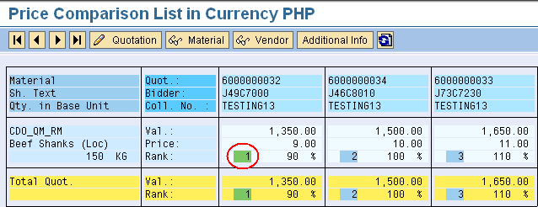

- If an item has been chosen, double click the rejected quoted item then put a tick mark on it as shown below. Press the Save icon. Repeat this step for all of the rejected quoted items. Note the RFQ numbers that have been approved to be used on creating Contract.
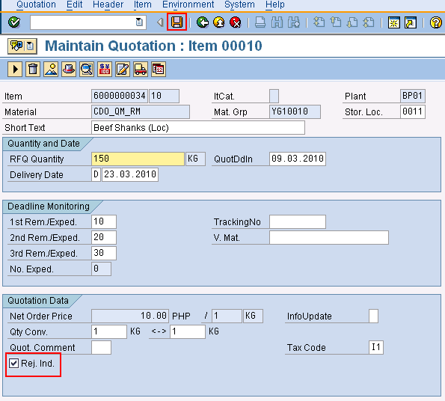

Result
You can compare the material prices quoted by different vendors. This comparison enables you to purchase materials from the vendor offering the lowest prices.

Create Purchase Order

Use
A purchase order is the request or instruction from a purchasing organization to a vendor (external supplier) or a plant to deliver a certain quantity of material or to perform services at a certain date.

Procedure
1. Access the transaction using the following navigation option:
SAP Graphical User Interface (SAP GUI)
SAP menu | Logistics  Materials Management  Purchasing → Purchase Order  Create  Vendor/Supplying Plant Known
Transaction code | ME21N
- Choose the appropriate Order Type.
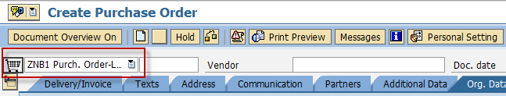
- Click the Document Overview On button.
- Choose the selection variant button to display purchasing documents created.
A purchase order may be in reference to a purchase requisition, a request for quotation, a contract, or based on another purchase order. It can also be created without any reference to another purchasing document. Details of the reference will be copied to the new purchase order being created.
- Choose reference as Purchase Requisitions (or any other purchasing document).
If the Purchase Requisition was referenced to a Request for Quotation (RFQ) document, choose
Request for quotations from the options instead of Purchase Requisitions.
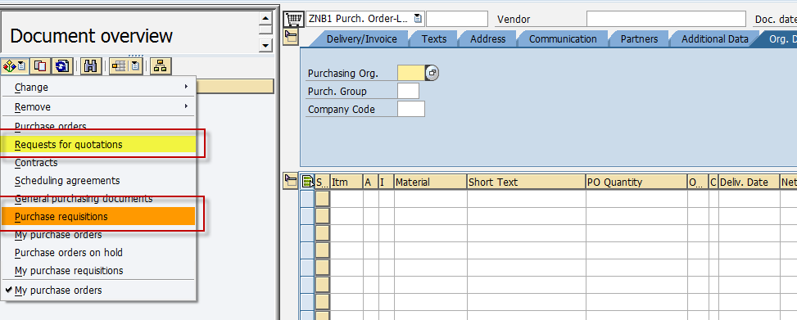
- A parameter selection screen is displayed to search for the purchasing document.
- A list of all the purchasing documents whether Purchase Requisitions or Request for Quotations depending on the selected criteria, will be displayed in the Create Purchase Order screen.
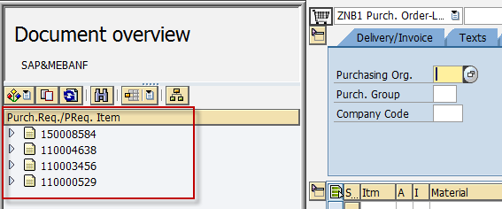
- Drag and drop the purchase requisition or any purchasing document selected to the shopping cart icon.
- The details of the document are copied to the purchase order being created.

- In the Header Portion of the screen, select Org. Data tab and make the following entries :
Field Name | User action and values | Remarks
Vendor | Choose from the list | Number and name of the vendor (external supplier) or supplying plant from which the materials are to be procured.
Purchasing Org. | Choose from the list | Denotes the purchasing organization
Purch. Group | Choose from the list | Key for a buyer or a group of buyers, who is/are responsible for certain purchasing activities.
Company Code | BP01 | The company code is an organizational unit within financial accounting.
- In the Item Overview, make the following entries :
Field Name | User action and values | Remarks
A | Choose from the list -  Blank for stock items  A – Asset  K – Cost Center | Account Assignment – Specifies whether accounting for an item is to be effected via an auxiliary account.
I | Choose from the list -  Blank for standard  K – Consignment  L – Subcontracting  D - Service | Item Category – Key defining  how the procurement of a  material or service item is  controlled.
Material | Choose from the list | Enter a material number if you  want to order a material with a  material master record.
PO Quantity |  | Quantity ordered by the buyer, to  be supplied by the vendor.
Plnt | Choose from the list | Plant in which you produce or for  which you wish to procure  materials or services.
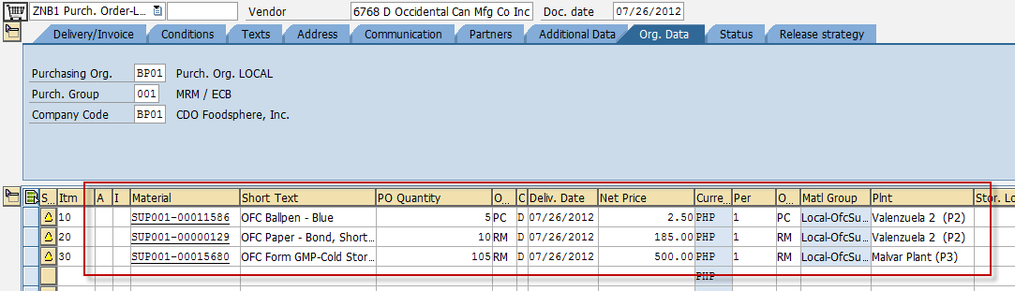
- In the Item Detail, select the Conditions tab and make the following entries :
Field Name | User action and values | Remarks
Amount |  | Determines how the system calculates pricing using this condition
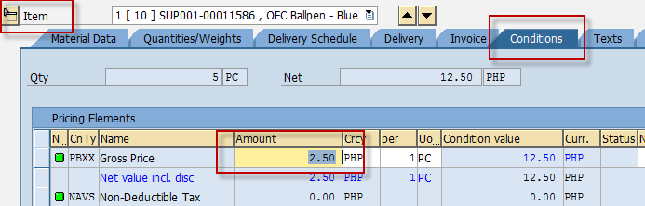
- In the Item Detail, select the Invoice tab and enter Tax Code:
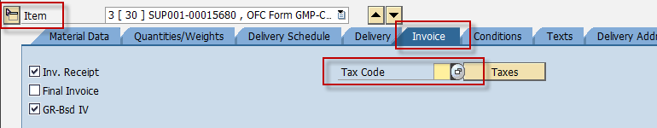
- If the Item being used is a generic material, an error with message “Please enter an MPN material…” will appear. Select the Material Data tab and at the Search Help of MPN material field, enter and choose the appropriate brand for the item.

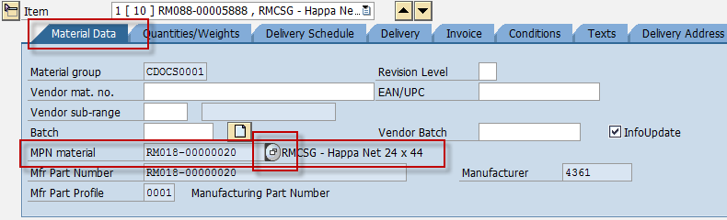

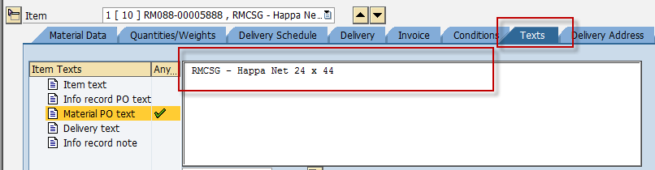
- In the Item Detail, select the Text tab and enter text entries:
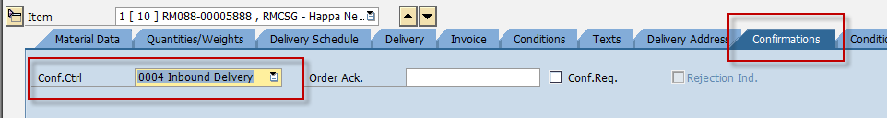
- In the Item Detail, select the Confirmations tab and choose Inbound Delivery as Confirmation Control:

- Click Check icon or Ctrl + Shift + F3.
- A dialog box appears containing system messages. Confirm warning messages. An error message will prevent you from saving the document.
- Confirm messages by pressing Enter.
- Click Save.
Result
Purchase Order Created. A message “Purchase Order-XXX created under the number 47XXXXXXXX” is displayed in the status bar.
After a succesful creation, the P.O. Number will then be manually recorded by the Buyer onto his/her plotting sheet to keep track and monitor the status of the P.O. particularly if it is not yet printed or already printed.
To change/edit/block/delete the Purchase Order, go to transaction ME22N.
To display the purchase order, go to transaction ME23N.

Release Purchase Order

Procedure
- Access the transaction using the following navigation option:
SAP Graphical User Interface (SAP GUI)
SAP menu | Logistics  Materials Management  Purchasing  Purchase Order  Release  Individual Release
Transaction code | ME29N
- In the Release Purchase Ord. - Local XXXXXXXXX: Initial Screen, Go to Purchase Order > Other Purchase Order or click the icon to select a document other than the last displayed by the system.
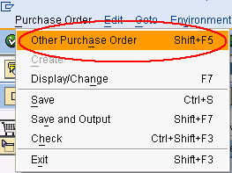
- A Select Document dialog box will appears. Enter the Purchase order number and press Enter.
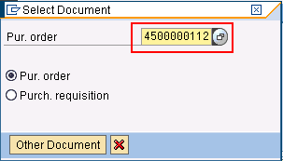
- In the Header portion of the screen, select the Release Strategy tab.
- Press the Release icon to release/approve the Purchase Order.
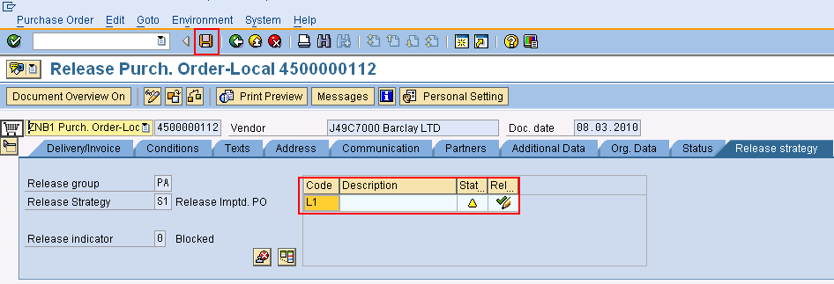
- When the Release button is pressed, the Release indicator will then change from 0 to 1 for release.
- Click Save icon to save the changes in the document.
To cancel the release, go to the Release Strategy tab and press the Release icon to unreleased the Purchase Order. Click Save icon to save the changes in the document.

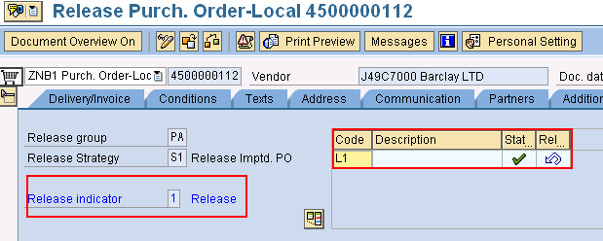

Result

The Purchase Order is now approved. A message “Release effected with release code XX” is displayed in the status bar. Please refer to Appendix B for the PO Release Strategy matrix.

Print Purchase Order

Procedure
- Access the transaction using the following navigation option:
SAP Graphical User Interface (SAP GUI)
SAP menu | Logistics  Materials Management  Purchasing → Purchase Order  Messages  Print/Transmit
Transaction code | ME9F
- In the Message Output screen, enter the purchase order number to be printed in the Document Number field, and/or enter selection parameters.
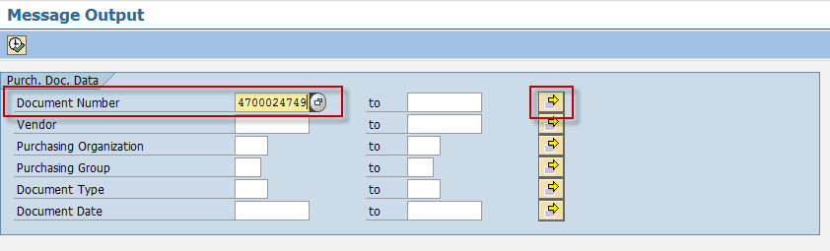
- Click the Execute icon.
- In the succeeding screen, select the purchasing document to be printed. Choose to process the document.
- Choose to preview the document.
- A print preview will be displayed.
- Choose icon or function F3 to go back to the Message Output screen.
- Go to List → Print.
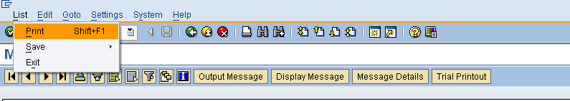

- A print ALV List dialog box is displayed. Make the following entries:
Field Name | User action and values | Comment
Output device |  | Printer name
Number of copies

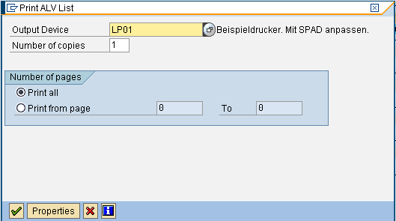
9. Choose icon.

Result

The Purchase Order document is printed.

APPENDIX A – PO Process Flow Chart
Start
A
Display
Purchase Requisition
ME5A
Request for Quotation
Required?
Y
View Purchase Order?
B
B

Create Purchase Order
ME21N

A
Change Purchase Order?
Change/Block/Delete Purchase Order
ME22N

N
N
Y

Create Request for Quotation (RFQ)
ME41

Maintain Request for Quotation (RFQ)
ME47

N

Price Comparison
ME49

Y

Display Purchase Order
ME23N

B
Release/Approve Purchase Order
ME29N

B

Purchase Order Completely Released?

Print Purchase Order
ME9F

End
Y
N

