|  |
| --- |
| English |
| **Breakthrough Methodology**  **Business Process Procedure** |
|  |
|  |
|  |

Purchase Requisition

|  |  |
| --- | --- |
| Breakthrough Methodology  July March 2001 2009  EnglishEnglish |  |

### 

Project: CDO Foodsphere Inc.

Prepared By: Michael Mendoza Mella, CpE

SAP MM/WM Specialist

Sr. SAP ABAP Developer

Strictly Confidential

#### Icons

|  |  |
| --- | --- |
| Icon | Meaning |
| achtung | Caution |
| example | Example |
| tip | Note |
| recommen | Recommendation |
| syntaxic | Syntax |

#### Typographic Conventions

|  |  |
| --- | --- |
| Type Style | Description |
| Example text | Words or characters that appear on the screen. These include field names, screen titles, pushbuttons as well as menu names, paths and options.  Cross-references to other documentation. |
| **Example text** | Emphasized words or phrases in body text, titles of graphics and tables. |
| EXAMPLE TEXT | Names of elements in the system. These include report names, program names, transaction codes, table names, and individual key words of a programming language, when surrounded by body text, for example, SELECT and INCLUDE. |
| Example text | Screen output. This includes file and directory names and their paths, messages, source code, names of variables and parameters as well as names of installation, upgrade and database tools. |
| EXAMPLE TEXT | Keys on the keyboard, for example, function keys (such as F2) or the ENTER key. |
| Example text | Exact user entry. These are words or characters that you enter in the system exactly as they appear in the documentation. |
| <Example text> | Variable user entry. Pointed brackets indicate that you replace these words and characters with appropriate entries. |

# 

# Creating Purchase Requisition for Stock (Inventory) Items

**Use**

This activity is performed to create a Purchase Requisition for stock items.

Procedure

1. Access the transaction using any of the following navigation options:

|  |  |
| --- | --- |
| **SAP menu** | *Logistics → Materials Management → Purchasing → Purchase Requisition → Create* |
| **Transaction code** | ME51N |

1. On the *Create Purchase Requisition* Initial Screen, make the following entries:

|  |  |  |
| --- | --- | --- |
| **Field Name** | **User action and values** | **Comment** |
| **Header Overview** |  |  |
| Document Type | Choose from the dropdown list:  **ZNB1** Purchase Req. - Local  **ZNB2** Purchase Req. - Imptd.  **ZNB6** Property PR - Local.  **ZNB7** Property PR - Imptd. | Allows a distinction to be made between various kinds of [purchase requisition](SAPEVENT:DOCU_LINK\DS:GLOS.3526C0C5AFAB52B9E10000009B38F974). |
| Header Note | Long text | Input supporting text if needed |
| **Item Overview** |  |  |
| Acct Assgt Cat. | Choose from the dropdown list:  **Blank** or **Space** – Stock Items | Specifies whether accounting for an item is to be effected via an auxiliary account (such as a [cost center](SAPEVENT:DOCU_LINK\DS:GLOS.3526B5D5AFAB52B9E10000009B38F974)). |
| Item Cat. | Choose from the dropdown list:  **Blank** or **Space** | Key defining how the procurement of a material or service item is controlled. |
| Material | Choose from the dropdown list | Alphanumeric key uniquely identifying the [material](SAPEVENT:DOCU_LINK\DS:GLOS.material) to be requested. |
| Quantity | Numeric value | Quantity of the material to be requested |
| Delivery Date | Date value | Date on which the goods are to be delivered |
| Plant | Choose from the dropdown list | Plant in which you wish to procure the material |
| Stor. Loc. | Choose from the dropdown list | Storage Location |
| PGr. | Choose from the dropdown list | Purchasing Group |
| Requisnr. | Choose from the dropdown list | Cost Center of Requisitioner |
| Tracking Number | Text value | Name of the Requisitioner |

1. 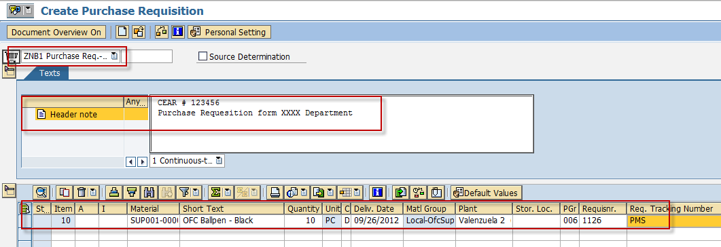Click the icon  to check the completeness of the required fields. If there are no error(s), a status toolbar will display a message with -

“No messages issued during check”.

1. Click the *Save*  icon to save the purchase requisition.

Result

A purchase requisition is created. The status toolbar displays a message -

 Purchase requisition number XXXXXXXXXX created.

# Creating Purchase Requisition for Non-Stock and Direct Expense Items

**Use**

This activity is performed to create a Purchase Requisition for non-stock and direct expense items.

Procedure

1. Access the transaction using any of the following navigation options:

|  |  |
| --- | --- |
| **SAP menu** | *Logistics → Materials Management → Purchasing → Purchase Requisition → Create* |
| **Transaction code** | ME51N |

1. On the *Create Purchase Requisition* Initial Screen, make the following entries:

|  |  |  |
| --- | --- | --- |
| **Field Name** | **User action and values** | **Comment** |
| **Header Overview** |  |  |
| Document Type | Choose from the dropdown list:  **ZNB1** Purchase Req. - Local  **ZNB2** Purchase Req. - Imptd.  **ZNB6** Property PR - Local.  **ZNB7** Property PR - Imptd. | Allows a distinction to be made between various kinds of [purchase requisition](SAPEVENT:DOCU_LINK\DS:GLOS.3526C0C5AFAB52B9E10000009B38F974). |
| Header Note | Long text | Input supporting text if needed |
| **Item Overview** |  |  |
| Acct Assgt Cat. | Choose from the dropdown list:  **F –** Order  **K** – Cost Center | Specifies whether accounting for an item is to be effected via an auxiliary account (such as a [cost center](SAPEVENT:DOCU_LINK\DS:GLOS.3526B5D5AFAB52B9E10000009B38F974)). |
| Item Cat. | Choose from the dropdown list:  Blank or Space | Key defining how the procurement of a material or service item is controlled. |
| Material | Choose from the dropdown list | Alphanumeric key uniquely identifying the [material](SAPEVENT:DOCU_LINK\DS:GLOS.material) to be requested. |
| Quantity | Numeric value | Quantity of the material to be requested |
| Delivery Date | Date value | Date on which the goods are to be delivered |
| Plant | Choose from the dropdown list | Plant in which you wish to procure the material |
| Stor. Loc. | Choose from the dropdown list | Storage Location |
| PGr. | Choose from the dropdown list | Purchasing Group |
| Requisnr. | Choose from the dropdown list | Cost Center of Requisitioner  achtung  If ***No*** ***Release Strategy Error*** occurs, input PMS Cost Center instead *(1126 or 1126-P3)*. |
| Tracking Number | Text value | Name of the Requisitioner |

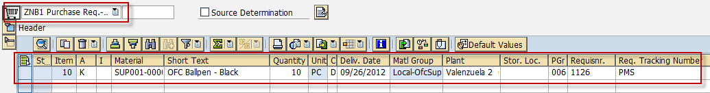

1. On Account Assignment Tab, specify the cost center of the requisitioner and the G/L Account Number.

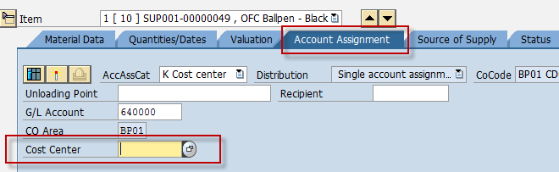

1. Click the icon  to check the completeness of the required fields. If there are no error(s), a status toolbar will display a message with -

“No messages issued during check”.

1. Click the *Save*  icon to save the purchase requisition.

Result

A purchase requisition is created. The status toolbar displays a message -

 Purchase requisition number XXXXXXXXXX created.

# Creating Purchase Requisition for Assets

**Use**

This activity is performed to create a Purchase Requisition for assets.

Procedure

1. Access the transaction using any of the following navigation options:

|  |  |
| --- | --- |
| **SAP menu** | *Logistics → Materials Management → Purchasing → Purchase Requisition → Create* |
| **Transaction code** | ME51N |

1. On the *Create Purchase Requisition* Initial Screen, make the following entries:

|  |  |  |
| --- | --- | --- |
| **Field Name** | **User action and values** | **Comment** |
| **Header Overview** |  |  |
| Document Type | Choose from the dropdown list:  **ZNB1** Purchase Req. - Local  **ZNB2** Purchase Req. - Imptd.  **ZNB6** Property PR - Local.  **ZNB7** Property PR - Imptd. | Allows a distinction to be made between various kinds of [purchase requisition](SAPEVENT:DOCU_LINK\DS:GLOS.3526C0C5AFAB52B9E10000009B38F974). |
| Header Note | Long text | Input supporting text if needed |
| **Item Overview** |  |  |
| Acct Assgt Cat. | Choose from the dropdown list:  **A –** Asset | Specifies whether accounting for an item is to be effected via an auxiliary account (such as a [cost center](SAPEVENT:DOCU_LINK\DS:GLOS.3526B5D5AFAB52B9E10000009B38F974)). |
| Item Cat. | Choose from the dropdown list:  Blank or Space | Key defining how the procurement of a material or service item is controlled. |
| Material | Choose from the dropdown list | Alphanumeric key uniquely identifying the [material](SAPEVENT:DOCU_LINK\DS:GLOS.material) to be requested. |
| Quantity | Numeric value | Quantity of the material to be requested |
| Delivery Date | Date value | Date on which the goods are to be delivered |
| Plant | Choose from the dropdown list | Plant in which you wish to procure the material |
| Stor. Loc. | Choose from the dropdown list | Storage Location |
| PGr. | Choose from the dropdown list | Purchasing Group |
| Requisnr. | Choose from the dropdown list | Cost Center of Requisitioner |
| Tracking Number | Text value | Name of the Requisitioner |

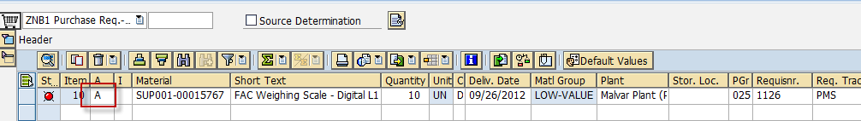

1. On Account Assignment Tab, specify the asset number which the item is to be assigned.

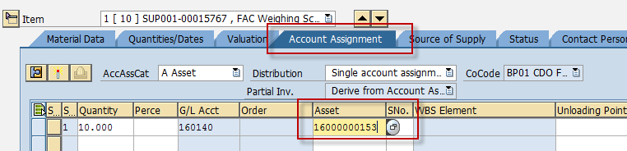

1. Click the icon  to check the completeness of the required fields. If there are no error(s), a status toolbar will display a message with -

“No messages issued during check”.

1. Click the *Save*  icon to save the purchase requisition.

Result

A purchase requisition is created. The status toolbar displays a message -

 Purchase requisition number XXXXXXXXXX created.

# Creating Purchase Requisition for Non-Valuated Materials

**Use**

This activity is performed to create a Purchase Requisition for non-valuated materials.

Procedure

1. Access the transaction using any of the following navigation options:

|  |  |
| --- | --- |
| **SAP menu** | *Logistics → Materials Management → Purchasing → Purchase Requisition → Create* |
| **Transaction code** | ME51N |

1. On the *Create Purchase Requisition* Initial Screen, make the following entries:

|  |  |  |
| --- | --- | --- |
| **Field Name** | **User action and values** | **Comment** |
| **Header Overview** |  |  |
| Document Type | Choose from the dropdown list:  **ZNB1** Purchase Req. - Local  **ZNB2** Purchase Req. - Imptd.  **ZNB6** Property PR - Local.  **ZNB7** Property PR - Imptd. | Allows a distinction to be made between various kinds of [purchase requisition](SAPEVENT:DOCU_LINK\DS:GLOS.3526C0C5AFAB52B9E10000009B38F974). |
| Header Note | Long text | Input supporting text if needed |
| **Item Overview** |  |  |
| Acct Assgt Cat. | Choose from the dropdown list:  **K –** Cost Center | Specifies whether accounting for an item is to be effected via an auxiliary account (such as a [cost center](SAPEVENT:DOCU_LINK\DS:GLOS.3526B5D5AFAB52B9E10000009B38F974)). |
| Item Cat. | Choose from the dropdown list:  Blank or Space | Key defining how the procurement of a material or service item is controlled. |
| Material | Choose from the dropdown list. | Alphanumeric key uniquely identifying the [material](SAPEVENT:DOCU_LINK\DS:GLOS.material) to be requested. |
| Quantity | Numeric value | Quantity of the material to be requested |
| Delivery Date | Date value | Date on which the goods are to be delivered |
| Plant | Choose from the dropdown list | Plant in which you wish to procure the material |
| Stor. Loc. | Choose from the dropdown list | Storage Location |
| PGr. | Choose from the dropdown list | Purchasing Group |
| Requisnr. | Choose from the dropdown list | Cost Center of Requisitioner  achtung  If ***No*** ***Release Strategy Error*** occurs, input PMS Cost Center instead *(1126 or 1126-P3)*. |
| Tracking Number | Text value | Name of the Requisitioner |



1. On Account Assignment Tab, specify the G/L Account number and Cost Center on which the item is to be assigned.

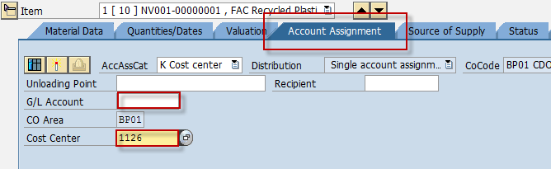

1. On Valuation Tab, input an amount, *e.g. PHP 1.00*, on the Valuation Price input field. Uncheck the **Inv. Receipt** Indicator and tick the **GR Non-Val.** Indicator.

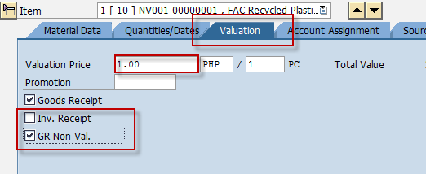

tip Please note that the amount entered in the *Valuation Price* field has no significance on the item’s valuation since it is a non-valuated material. The *Valuation Price* will only be used by the system to determine the Release Strategy of the purchase requisition.

1. Click the icon  to check the completeness of the required fields. If there are no error(s), a status toolbar will display a message with -

“No messages issued during check”.

1. Click the *Save*  icon to save the purchase requisition.

Result

A purchase requisition is created. The status toolbar displays a message -

 Purchase requisition number XXXXXXXXXX created.

# Creating Purchase Requisition for Subcontracting

**Use**

This activity is performed to create a Purchase Requisition for subcontracting.

Procedure

1. Access the transaction using any of the following navigation options:

|  |  |
| --- | --- |
| **SAP menu** | *Logistics → Materials Management → Purchasing → Purchase Requisition → Create* |
| **Transaction code** | ME51N |

1. On the *Create Purchase Requisition* Initial Screen, make the following entries:

|  |  |  |
| --- | --- | --- |
| **Field Name** | **User action and values** | **Comment** |
| **Header Overview** |  |  |
| Document Type | Choose from the dropdown list:  **ZNB1** Purchase Req. - Local  **ZNB2** Purchase Req. - Imptd.  **ZNB6** Property PR - Local.  **ZNB7** Property PR - Imptd. | Allows a distinction to be made between various kinds of [purchase requisition](SAPEVENT:DOCU_LINK\DS:GLOS.3526C0C5AFAB52B9E10000009B38F974). |
| Header Note | Long text | Input supporting text if needed |
| **Item Overview** |  |  |
| Acct Assgt Cat. | Choose from the dropdown list:  **Blank or Space** | Specifies whether accounting for an item is to be effected via an auxiliary account (such as a [cost center](SAPEVENT:DOCU_LINK\DS:GLOS.3526B5D5AFAB52B9E10000009B38F974)). |
| Item Cat. | Choose from the dropdown list:  **L** - Subcontracting | Key defining how the procurement of a material or service item is controlled. |
| Material | Choose from the dropdown list | Alphanumeric key uniquely identifying the [material](SAPEVENT:DOCU_LINK\DS:GLOS.material) to be requested. |
| Quantity | Numeric value | Quantity of the material to be requested |
| Delivery Date | Date value | Date on which the goods are to be delivered |
| Plant | Choose from the dropdown list | Plant in which you wish to procure the material |
| Stor. Loc. | Choose from the dropdown list | Storage Location |
| PGr. | Choose from the dropdown list | Purchasing Group |
| Requisnr. | Choose from the dropdown list | Cost Center of Requisitioner |
| Tracking Number | Text value | Name of the Requisitioner |

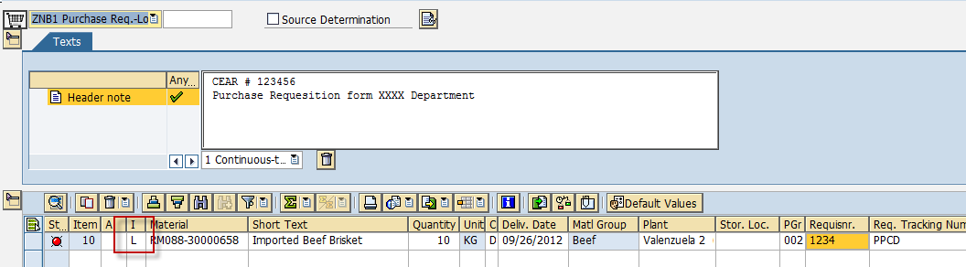

1. On Material Data Tab, specify the components of the material.

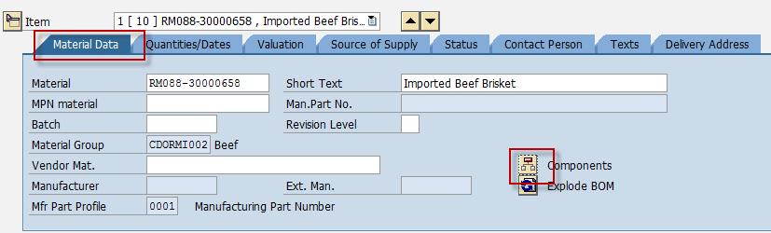

1. Click the icon  to check the completeness of the required fields. If there are no error(s), a status toolbar will display a message with -

“No messages issued during check”.

1. Click the *Save*  icon to save the purchase requisition.

Result

A purchase requisition is created. The status toolbar displays a message -

 Purchase requisition number XXXXXXXXXX created.

## Approval of Purchase Requisitions

**Use**

If the purchase requisition you created is subject to a release procedure (for example, total net order value > 5000 PHP), you have to go through these transaction steps.

Procedure

1. Access the transaction using the following navigation option:

|  |  |
| --- | --- |
| **SAP menu** | *Logistics → Materials Management → Purchasing → Purchase Requisition → Release → Individual Release* |
| **Transaction Code** | ME54N |

1. On the Release Purchase Requisition screen, go to **Purchase Requisition → Other Requisition**.

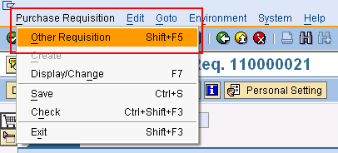

1. Enter the purchase requisition number.
2. Click the icon  to edit the purchase requisition.
3. To approve the requisition, click on the Release Button (marked by a “pencil”).

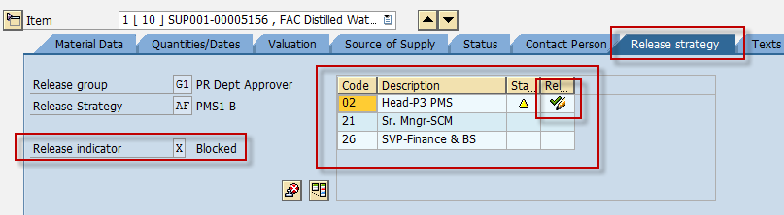

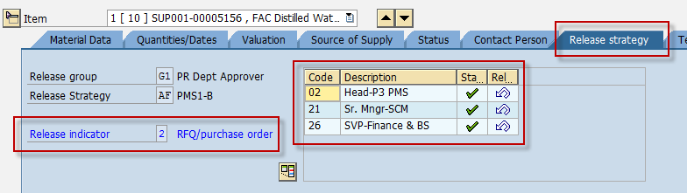

1. Click the *Save*  icon to save the changes of the document.

Result

The purchase requisition is released. But the purchase requisition may need to be released by multiple people depending on the release strategy set in Customizing. Once the last person has released the purchase requisition, the buyer/planner can convert the purchase requisition into a Purchase Order.

The status bar displays a message.

.

tip To edit a purchase requisition, access the transaction:

|  |  |
| --- | --- |
| **SAP menu** | *Logistics → Materials Management → Purchasing → Purchase Requisition → Change* |
| **Transaction Code** | ME52N |

Proceed with the approval of the purchase requsition.

tip To display a purchase requisition, access the transaction:

|  |  |
| --- | --- |
| **SAP menu** | *Logistics → Materials Management → Purchasing → Purchase Requisition → Display* |
| **Transaction Code** | ME53N |