|  |
| --- |
| English |
| **Breakthrough Methodology**  **Business Process Procedure** |
|  |
|  |
|  |

Receiving Report of

Imported Items

(Casing, Meats, and Spices)

|  |  |
| --- | --- |
| Breakthrough Methodology  July March 2001 2009  EnglishEnglish |  |

### 

Project : CDO Foodsphere Inc.

Prepared By : Michael Mendoza Mella, CpE

SAP MM Specialist, MIS

Strictly Confidential

#### Icons

|  |  |
| --- | --- |
| Icon | Meaning |
| achtung | Caution |
| example | Example |
| tip | Note |
| recommen | Recommendation |
| syntaxic | Syntax |

#### Typographic Conventions

|  |  |
| --- | --- |
| Type Style | Description |
| Example text | Words or characters that appear on the screen. These include field names, screen titles, pushbuttons as well as menu names, paths and options.  Cross-references to other documentation. |
| **Example text** | Emphasized words or phrases in body text, titles of graphics and tables. |
| EXAMPLE TEXT | Names of elements in the system. These include report names, program names, transaction codes, table names, and individual key words of a programming language, when surrounded by body text, for example, SELECT and INCLUDE. |
| Example text | Screen output. This includes file and directory names and their paths, messages, source code, names of variables and parameters as well as names of installation, upgrade and database tools. |
| EXAMPLE TEXT | Keys on the keyboard, for example, function keys (such as F2) or the ENTER key. |
| Example text | Exact user entry. These are words or characters that you enter in the system exactly as they appear in the documentation. |
| <Example text> | Variable user entry. Pointed brackets indicate that you replace these words and characters with appropriate entries. |

# 

# 

# Receiving Report of Imported Items (Casing, Meats, and Spices)

**Use**

This facility is used to display detailed receiving report of imported casings, meats and spices based on a specified purchase requisition date.

Procedure

1. Access the transaction using following navigation options:

|  |  |
| --- | --- |
| **Transaction code** | ZMM071 |

1. On the *Receiving Report of Imported Materials: Selection Screen Filters* frame, make the following entries as necessary/applicable:

|  |  |  |
| --- | --- | --- |
| **Field Name** | **User action and values** | **Comment** |
| Requisition Date | **Required** | Date range on which the PRCS was created in the SAP system |
| Plant | **BP02, BP03** | Plant on which the document is intended to receive |
| Vendor | Optional | Code of the supplier/vendor |
| Purchase Requisition | Optional | PRCS number. Input a value on this field to filter an specific PRCS number |
| Purchasing Document | Optional | PO number. Input a value on this field to filter an specific PO number |
| G.R. Number | Optional | Goods receipt number associated in the purchasing documents |
| Material | Optional | Material associated under the purchasing documents |

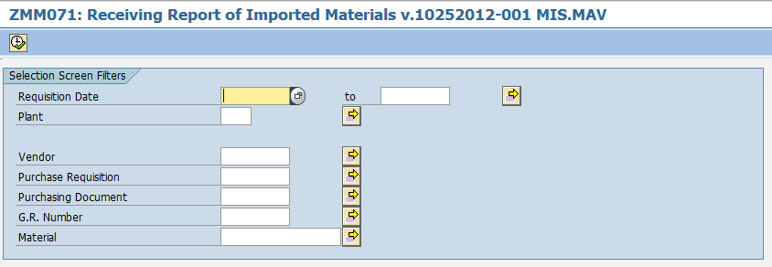

1. On the *Receiving Report of Imported Materials: Material Group* frame tab, select at least one in any of the following format you want to display.

|  |  |
| --- | --- |
| **Field Name** | **Comment** |
| Casing | Receiving Report of Imported Casings |
| Meats and Spices | Receiving Report of Imported Meats and Spices |

achtung If none of these options has selected, an error message will be displayed informing you need to select at least one option from the two check boxes.

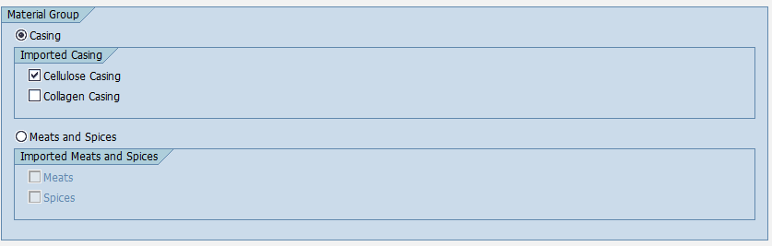

1. Click the *Execute*  icon. The program will display the list based on your selections.

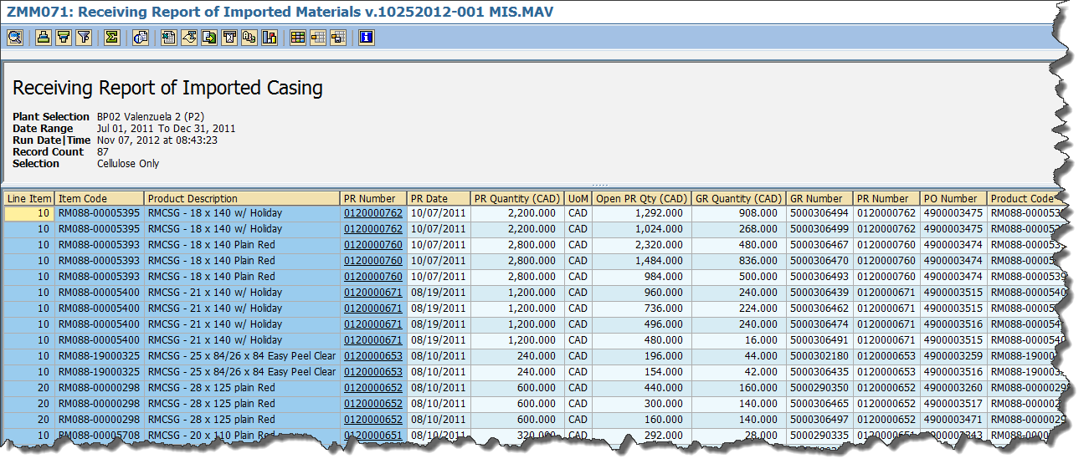

1. To view the details of the purchase requisition, simply click the PR Number and the program will redirect you to **ME53N – Display Purchase Requisition** transaction.

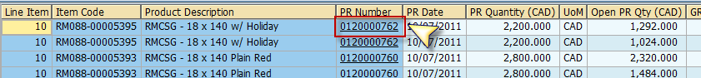

1. To view the details of the GR, simply click the GR Number and the program will redirect you to **MIGO – Display Material Document** transaction.

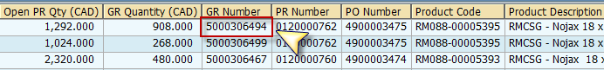

1. To export the list as a local file (MS Excel Format), click the *Local file * icon on top the screen or press **Ctrl + Shift + F9**.

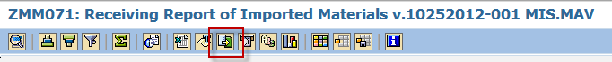

1. A popup dialog box will appear. Choose Spreadsheet option.

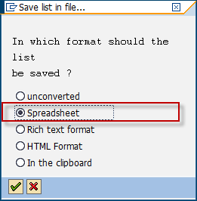

1. The system will then ask you the directory and filename of the file. Specify the location on which you wish to save the excel file and give a descriptive filename. Click *Generate* button.

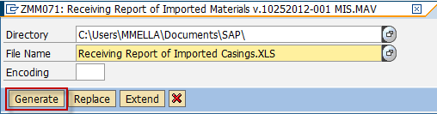

1. The list has been exported to specified destination.



1. Click *Back*  button to go back to the initial screen to select other formats.

