Breakthrough Methodology
Business Process Procedure

Releasing of
Purchase Requisitions

Breakthrough Methodology
July 2009
English
Project: CDO Foodsphere Inc.
Prepared By: Michael Mendoza Mella, CpE
SAP MM Specialist

Strictly Confidential

Icons

Icon | Meaning
 | Caution
 | Example
 | Note
 | Recommendation
 | Syntax

Typographic Conventions

Type Style | Description
Example text | Words or characters that appear on the screen. These include field names, screen titles, pushbuttons as well as menu names, paths and options.  Cross-references to other documentation.
Example text | Emphasized words or phrases in body text, titles of graphics and tables.
EXAMPLE TEXT | Names of elements in the system. These include report names, program names, transaction codes, table names, and individual key words of a programming language, when surrounded by body text, for example, SELECT and INCLUDE.
Example text | Screen output. This includes file and directory names and their paths, messages, source code, names of variables and parameters as well as names of installation, upgrade and database tools.
EXAMPLE TEXT | Keys on the keyboard, for example, function keys (such as F2) or the ENTER key.
Example text | Exact user entry. These are words or characters that you enter in the system exactly as they appear in the documentation.
<Example text> | Variable user entry. Pointed brackets indicate that you replace these words and characters with appropriate entries.

Approval of Purchase Requisitions (Collective Release)

Procedure

- Access the transaction using the following navigation option:
SAP menu | Logistics → Materials Management → Purchasing → Purchase Requisition → Release → Collective Release
Transaction Code | ME55
- On the Collective Release Purchase Requisition initial screen, make the following entries:
Field Name | User action and values | Comment
Release Code | 21 - Sr. Mngr-SCM | Specifies the release code with which individual items of a purchase requisition or entire requisitions can be released (approved).
Release Group | G1 | Group of your release code belongs to.
Scope of list | ALV | ALV grid control.
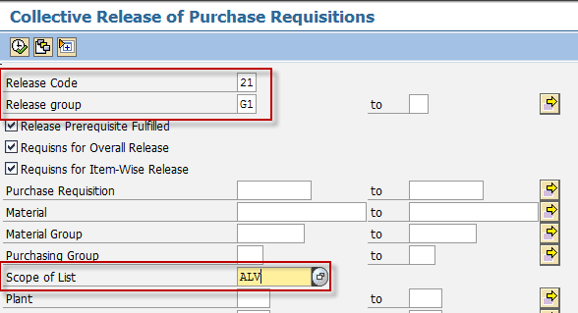
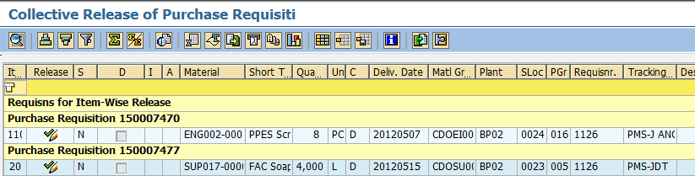
- Click the Execute button or press F8. The program will display list of purchase requisitions under of your approval.
- To approve the requisition, click on the Release Button (marked by a “pencil”).
- The pencil will then changed to check icon informing the PR has been released.

Result

The purchase requisition is released. But the purchase requisition may need to be released by multiple people depending on the release strategy set in Customizing. Once the last person has released the purchase requisition, the buyer/planner can convert the purchase requisition into a Purchase Order.
The status bar displays a message.
.

Approval of Purchase Requisitions (Individual Release)

Use
If the purchase requisition you created is subject to a release procedure (for example, total net order value > 5000 PHP), you have to go through these transaction steps.

Procedure

- Access the transaction using the following navigation option:
SAP menu | Logistics → Materials Management → Purchasing → Purchase Requisition → Release → Individual Release
Transaction Code | ME54N
- On the Release Purchase Requisition screen, go to Purchase Requisition → Other Requisition.
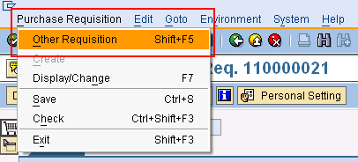
- Enter the purchase requisition number.
- Click the icon to edit the purchase requisition.
- To approve the requisition, click on the Release Button (marked by a “pencil”).
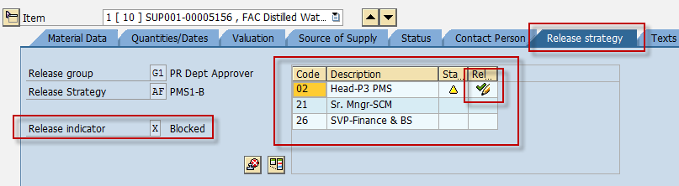

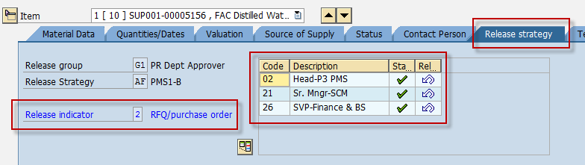

- Click the Save icon to save the changes of the document.

Result

The purchase requisition is released. But the purchase requisition may need to be released by multiple people depending on the release strategy set in Customizing. Once the last person has released the purchase requisition, the buyer/planner can convert the purchase requisition into a Purchase Order.
The status bar displays a message.
.
To edit a purchase requisition, access the transaction:
SAP menu | Logistics → Materials Management → Purchasing → Purchase Requisition → Change
Transaction Code | ME52N
Proceed with the approval of the purchase requsition.
To display a purchase requisition, access the transaction:
SAP menu | Logistics → Materials Management → Purchasing → Purchase Requisition → Display
Transaction Code | ME53N

