|  |
| --- |
| English |
| **Breakthrough Methodology**  **Business Process Procedure** |
|  |
|  |
|  |

Released Purchase Orders

Monitoring

Facility

|  |  |
| --- | --- |
| Breakthrough Methodology  July March 2001 2009  EnglishEnglish |  |

### 

Project: CDO Foodsphere Inc.

Prepared By: Michael Mendoza Mella, CpE

SAP MM/WM Specialist

Sr. SAP ABAP Developer

Strictly Confidential

#### Icons

|  |  |
| --- | --- |
| Icon | Meaning |
| achtung | Caution |
| example | Example |
| tip | Note |
| recommen | Recommendation |
| syntaxic | Syntax |

#### Typographic Conventions

|  |  |
| --- | --- |
| Type Style | Description |
| Example text | Words or characters that appear on the screen. These include field names, screen titles, pushbuttons as well as menu names, paths and options.  Cross-references to other documentation. |
| **Example text** | Emphasized words or phrases in body text, titles of graphics and tables. |
| EXAMPLE TEXT | Names of elements in the system. These include report names, program names, transaction codes, table names, and individual key words of a programming language, when surrounded by body text, for example, SELECT and INCLUDE. |
| Example text | Screen output. This includes file and directory names and their paths, messages, source code, names of variables and parameters as well as names of installation, upgrade and database tools. |
| EXAMPLE TEXT | Keys on the keyboard, for example, function keys (such as F2) or the ENTER key. |
| Example text | Exact user entry. These are words or characters that you enter in the system exactly as they appear in the documentation. |
| <Example text> | Variable user entry. Pointed brackets indicate that you replace these words and characters with appropriate entries. |

# 

# 

# Released Purchase Orders Monitoring Facility

**Use**

This facility is used to monitor and to track the status of all **released purchase orders** created for a certain period and to eliminate manual creation of reports regarding purchase orders.

Procedure

1. Access the transaction using following navigation options:

|  |  |
| --- | --- |
| **Transaction code** | ZMM068 |

1. On the *Purchase Order Transactions Monitoring : Selection Options*, make the following entries as necessary/applicable:

|  |  |  |
| --- | --- | --- |
| **Field Name** | **User action and values** | **Comment** |
| Purch. Doc. Date | Required | Date on which the PO was created |
| Purch. Group | Optional. | Code of person or group who created the purchasing document |
| Plant | Optional | Plant on which the document is intended to receive |
| Purch. Document | Optional | Purchase order number you wish to display |
| G.R. Number | Optional | Goods receipt number associated in the purchasing document |
| G.R. Date | Optional | Document date on which the goods or services is received |
| Supplier | Optional | Code of the supplier/vendor |
| Item Code | Optional | Material associated under the purchasing document |
| Material Group | Optional | Key use to group the materials or services with the same attributes |

1. On the *Purchase Order Transactions Monitoring: Document Type Selections* tab, select at least one in any of the following format you want to display.

|  |  |
| --- | --- |
| **Field Name** | **Comment** |
| Purch. Order – Local | Standard Purchase Orders Local Only (ZNB1) |
| Purch. Order – Imported | Standard Purchase Orders Imported Only (ZNB2) |

recommen You can select either document type or a certain single type to be displayed.

achtung If none of these options has selected, an error message will be displayed informing you need to select at least one document type.

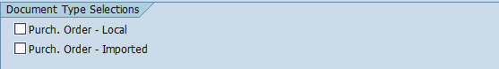

1. Click the *Execute*  icon. The program will display the list based on your selections.

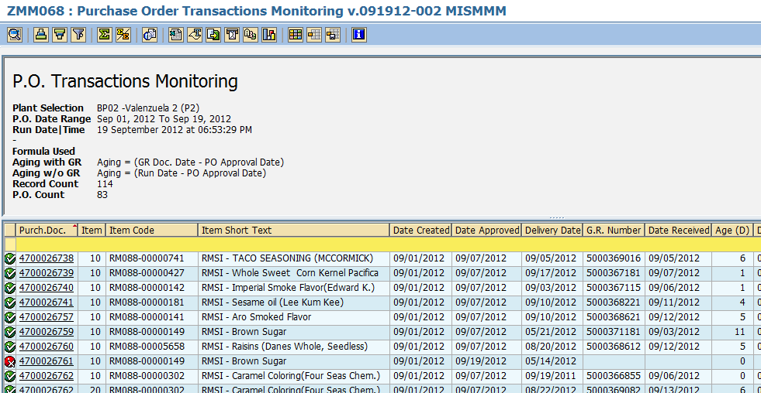

1. The icon  means that the PO Number next to it has not yet been delivered (No GR yet).



1. The icon  means that the PO Number next to it has already been delivered regardless if it is staggered delivery of not (GR already exist).



1. To view the details of the purchase order, simply click the PO Number and the program will redirect you to **ME23N – Display Purchase Order** transaction.

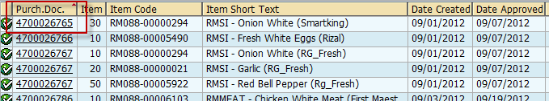

1. The ***Age*** field indicates the **age in days** of the document since the PO was approved until the **first delivery** of the document has been received. If the document **does not have a GR number yet**, age will be computed **from the date it was approved up to the current system date**. The formula of the age is displayed on the top of the screen.

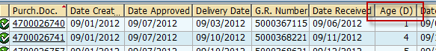

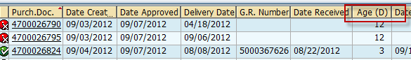

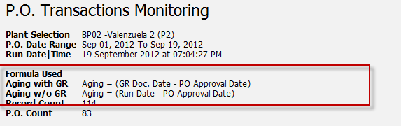

1. To export the list as a local file (MS Excel Format), click the *Local file * icon on top the screen or press **Ctrl + Shift + F9**.

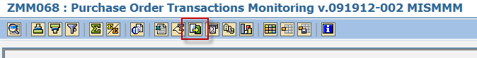

1. A popup dialog box will appear. Choose Spreadsheet option.

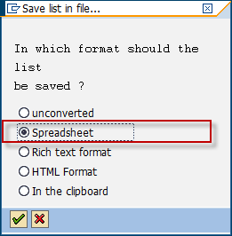

1. The system will then ask you the directory and filename of the file. Specify the location on which you wish to save the excel file and give a descriptive filename. Click *Generate* button.

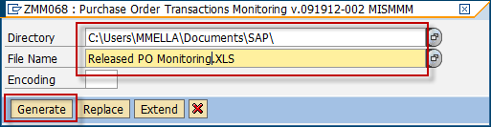

1. The list has been exported to specified destination.



1. Click *Back*  button to go back to the initial screen to select other formats.