|  |
| --- |
| English |
| **Breakthrough Methodology**  **Business Process Procedure** |
|  |
|  |
|  |

Released Purchase Requisitions

Monitoring

Facility

|  |  |
| --- | --- |
| Breakthrough Methodology  July March 2001 2009  EnglishEnglish |  |

### 

Project: CDO Foodsphere Inc.

Prepared By: Michael Mendoza Mella

Strictly Confidential

#### Icons

|  |  |
| --- | --- |
| Icon | Meaning |
| achtung | Caution |
| example | Example |
| tip | Note |
| recommen | Recommendation |
| syntaxic | Syntax |

#### Typographic Conventions

|  |  |
| --- | --- |
| Type Style | Description |
| Example text | Words or characters that appear on the screen. These include field names, screen titles, pushbuttons as well as menu names, paths and options.  Cross-references to other documentation. |
| **Example text** | Emphasized words or phrases in body text, titles of graphics and tables. |
| EXAMPLE TEXT | Names of elements in the system. These include report names, program names, transaction codes, table names, and individual key words of a programming language, when surrounded by body text, for example, SELECT and INCLUDE. |
| Example text | Screen output. This includes file and directory names and their paths, messages, source code, names of variables and parameters as well as names of installation, upgrade and database tools. |
| EXAMPLE TEXT | Keys on the keyboard, for example, function keys (such as F2) or the ENTER key. |
| Example text | Exact user entry. These are words or characters that you enter in the system exactly as they appear in the documentation. |
| <Example text> | Variable user entry. Pointed brackets indicate that you replace these words and characters with appropriate entries. |

# 

# 

# Released Purchase Requisitions Monitoring Facility

**Use**

This facility is used to monitor and to track the status of all **released purchase requisitions** created for a certain period and to eliminate manual creation of reports regarding purchase requisitions.

Procedure

1. Access the transaction using following navigation options:

|  |  |
| --- | --- |
| **Transaction code** | ZMM067 |

1. On the *Released PR Monitoring : Output Specifications* Initial Screen, make the following entries as necessary/applicable:

|  |  |  |
| --- | --- | --- |
| **Field Name** | **User action and values** | **Comment** |
| Requisition Date | Required | Date on which the PR was created |
| Plant | Optional. Value is recommended | Plant on where the PR was intended to receive |
| Purchasing Group | Optional | Purchasing Group |
| Material | Optional | Item code of the material included in the purchase request |
| Material Group | Optional | Key that you use to group together several [materials](SAPEVENT:DOCU_LINK\\DS:GLOS.material) or [services](SAPEVENT:DOCU_LINK\\DS:GLOS.service) with the same attributes |
| Requisitioner | Optional | Cost Center of the requesting dept. |
| Purchase Requisition | Optional | Purchase requisition number to display |
| Purchase Order | Optional | Purchase order number associated in the purchase requisition |
| Created by | Optional | Name of person who created the purchase requisition document |

1. On the *Released PR Monitoring: Document Type* tab, select at least one in any of the following format you want to display.

|  |  |
| --- | --- |
| **Field Name** | **Comment** |
| Standard PR – Local | Standard Purchase Requisitions Local Only (ZNB1) |
| Standard PR – Imported | Standard Purchase Requisitions Imported Only (ZNB2) |
| PMS PR – Local | Property Purchase Requisitions Local Only (ZNB6) |
| PMS PR – Imported | Property Purchase Requisitions Imported Only (ZNB6) |
| Subcontracting PR | Subcontracting Purchase Requisitions |

recommen You can select all document type, a combination, or a certain single type to be displayed.

achtung If none of these options has selected, an error message will be displayed informing you need to select at least one document type.

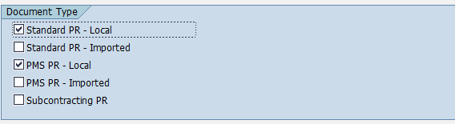

1. Click the *Execute*  icon. The program will display the list based on your selections.

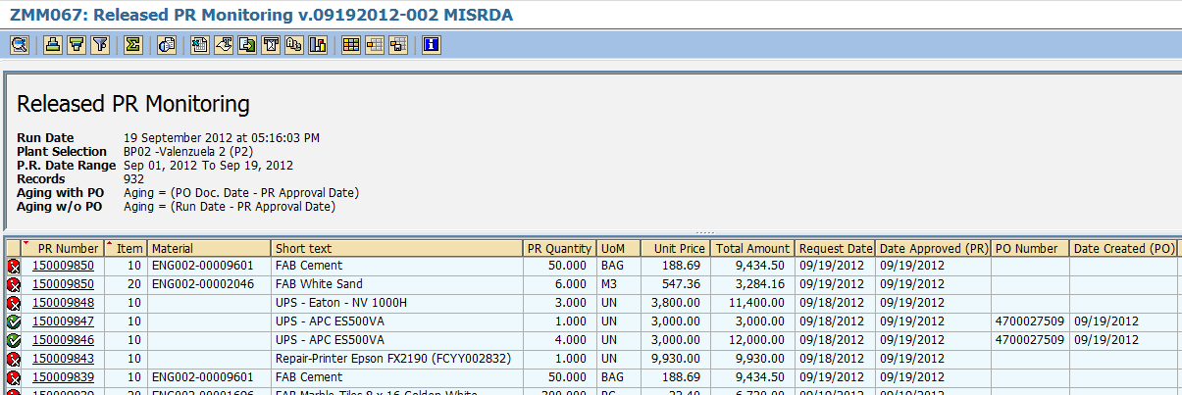

1. The icon  means that the PR number next to it has not yet been assigned to any Purchase Order number (PR is still open).



1. The icon  means that the PR number next to it has already converted into a Purchase Order.



1. To view the details of the purchase requisition, simply click the PR Number and the program will redirect you to **ME53N – View Purchase Requisition** transaction.

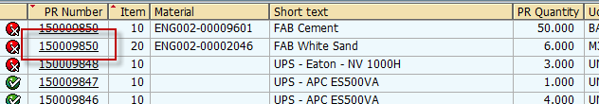

1. The ***Age*** field indicates the **age in days** of the document since the PR was approved until it was converted into a purchase order. The formula of the age is displayed on the top of the screen.

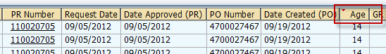

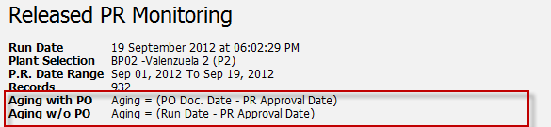

1. To export the list as a local file (MS Excel Format), click the *Local file * icon on top the screen or press **Ctrl + Shift + F9**.

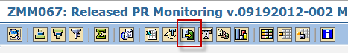

1. A popup dialog box will appear. Choose Spreadsheet option.

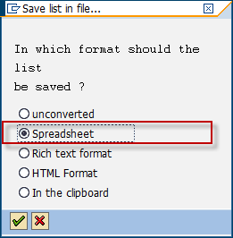

1. The system will then ask you the directory and filename of the file. Specify the location on which you wish to save the excel file and give a descriptive filename. Click *Generate* button.

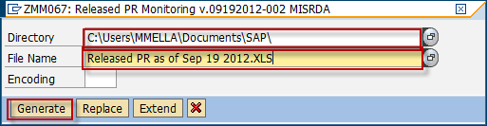

1. The list has been exported to specified destination.



1. Click *Back*  button to go back to the initial screen to select other formats.

