|  |
| --- |
| English |
| **Breakthrough Methodology**  **Business Process Procedure** |
|  |
|  |
|  |

Returnable Transport Packaging

From Vendor

|  |  |
| --- | --- |
| Breakthrough Methodology  July March 2001 2009  EnglishEnglish |  |

### 

Project: CDO Foodsphere Inc.

Prepared By: Michael Mendoza Mella

Strictly Confidential

#### Icons

|  |  |
| --- | --- |
| Icon | Meaning |
| achtung | Caution |
| example | Example |
| tip | Note |
| recommen | Recommendation |
| syntaxic | Syntax |

#### Typographic Conventions

|  |  |
| --- | --- |
| Type Style | Description |
| Example text | Words or characters that appear on the screen. These include field names, screen titles, pushbuttons as well as menu names, paths and options.  Cross-references to other documentation. |
| **Example text** | Emphasized words or phrases in body text, titles of graphics and tables. |
| EXAMPLE TEXT | Names of elements in the system. These include report names, program names, transaction codes, table names, and individual key words of a programming language, when surrounded by body text, for example, SELECT and INCLUDE. |
| Example text | Screen output. This includes file and directory names and their paths, messages, source code, names of variables and parameters as well as names of installation, upgrade and database tools. |
| EXAMPLE TEXT | Keys on the keyboard, for example, function keys (such as F2) or the ENTER key. |
| Example text | Exact user entry. These are words or characters that you enter in the system exactly as they appear in the documentation. |
| <Example text> | Variable user entry. Pointed brackets indicate that you replace these words and characters with appropriate entries. |

# 

# Goods Receipt against an Inbound Delivery

**Use**

This activity is performed to GR against an Inbound Delivery number and to post the stock with returnable packaging container/material in the inventory.

Procedure

1. Access the transaction using any of the following navigation options:

|  |  |
| --- | --- |
| **SAP menu** | *Logistics* → *Materials Management* → *Inventory Management*→ *Goods Movement*→ *MIGO* |
| **Transaction code** | MIGO |

1. In the MIGO screen, choose **A01 - Goods Receipt** with reference to **R04 - Inbound Delivery.**

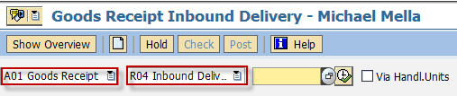

1. Input the Inbound Delivery Number or press **F4** to begin a search.
2. Make sure that the **movement type** at the right most part of the screen is **GR Goods Receipt 101**. Otherwise, type **101** in the box.

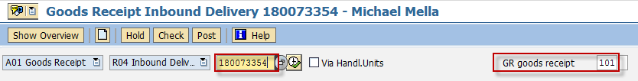

1. Press **Enter.** The details of the Inbound Delivery will be copied into the MIGO screen.
2. In the ***Header Data Area***, choose **General** tab and make the following entries as applicable:

| Field name | User action and values | Comment |
| --- | --- | --- |
|  | 3 Collective Slip | Print Active/Inactive |
| Delivery Note |  | Number of external Delivery Note |
| Header Text |  | Explanation or notes which apply to the document as a whole |

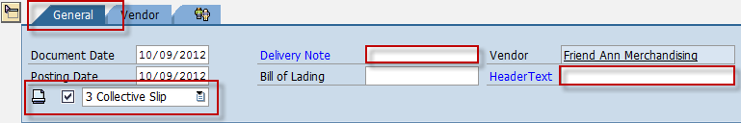

1. To include the *Returnable Transport Materia*l in the list, click the  *Transport Equipment* button. The system will create a new line item automatically on the MIGO Screen.



1. In the ***Detail Data Area***, choose **Material** tab and enter the item code of the *Returnable Transport Material* on the field provided.

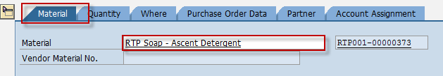

1. In the ***Detail Data Area***, choose **Quantity** tab and make the following entries as applicable:

| Field name | User action and values | Comment |
| --- | --- | --- |
| Qty in Unit of Entry | Numeric value | Enter the quantity of the RTP material to be received. |

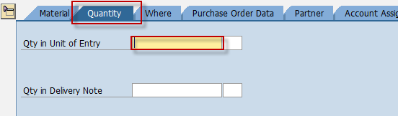

1. In the ***Detail Data Area***, choose **Where** tab and make the following entries as applicable:

| Field name | User action and values | Comment |
| --- | --- | --- |
| Movement Type | **501 M** | Movement Type for Receipt to RTP |
| Plant | **BP02, BP03** | Plant code |
| Storage Location | Choose from the dropdown list | Location on where you wish to store the material being received |
| Goods Recipient | Text value | Input additional name if necessary |
| Text | Text value | Input additional text if necessary |

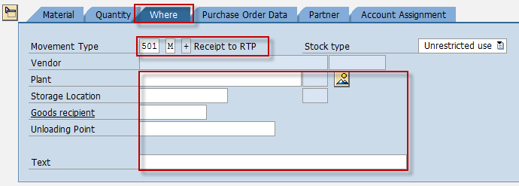

1. In the ***Detail Data Area***, choose **Partner** tab and make the following entries as applicable:

| Field name | User action and values | Comment |
| --- | --- | --- |
| Vendor |  | Specify the name of the vendor/supplier |

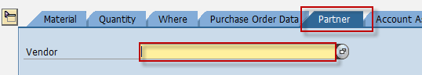

1. Tick the Item OK check box.



1. Set/input and tick the line item number to GR the principal item.



1. In the ***Detail Data Area***, choose **Quantity** tab and make the following entries as applicable:

| Field name | User action and values | Comment |
| --- | --- | --- |
| Qty in Unit of Entry | Numeric value | Change the default quantity if partial delivery. |

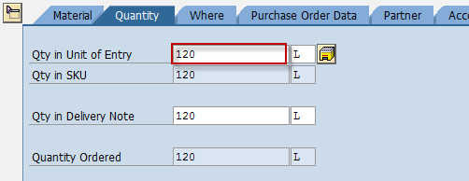

1. In the ***Detail Data Area***,, choose **Where** tab and make the following entries as applicable:

| Field name | User action and values | Comment |
| --- | --- | --- |
| Storage Location | Choose from the dropdown list | Location on where you wish to store the material being received |
| Goods Recipient | Text value | Input additional name if necessary |
| Text | Text value | Input additional text if necessary |

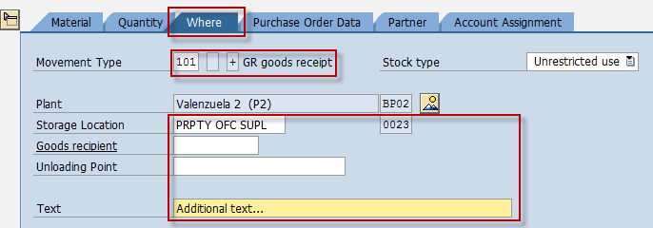

1. In the ***Detail Data Area***,, choose **Purchase Order Data** tab and make the following entries as applicable:

| Field name | User action and values | Comment |
| --- | --- | --- |
| Del. Completed Ind. | List Box | Choose **2 – Set**  Ifthere is no more expected delivery for this purchase order, that is, the PO is already closed. |

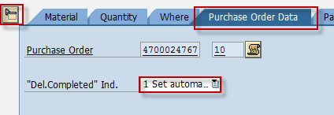

1. Click the *Check*  button.
2. A dialog box will appear containing system messages. Confirm all warning messages. Note that an **Error Message** will prevent you from posting the document.
3. Confirm messages by pressing **Enter**.
4. Click Save  icon or Post  button to post the document.

Result

1. A material document is created.
2. Stock of the *RTP* material on the inventory will increase. You can monitor the inventory of the Returnable Transport Packaging through transaction code **MMBE or MB51**.
3. The purchase order history tab of the PO is updated.
   1. Access the transaction using any of the following navigation options:

|  |  |
| --- | --- |
| **SAP menu** | *Logistics* → *Materials Management* → *Purchasing* → *Purchase Order → Display* |
| **Transaction code** | ME23N |

* 1. In the Standard PO screen, choose  icon.
  2. In the *Select Document dialog box,* enter the PO number,
  3. Press Enter.
  4. The Purchase Order is displayed. Notice a new tab added to the Purchase Order: **Purchase Order History**. The tab is updated by the goods receipt done.

# Print Goods Receipt Slip

**Use**

This activity is performed to print GR Slip.

Procedure

1. Access the transaction using any of the following navigation options:

|  |  |
| --- | --- |
| **SAP menu** | *Logistics* → *Materials Management* → *Inventory Management*→ *Material Document 🡪 Process Output* |
| **Transaction code** | MB90 |

1. In the *Output from Goods Movement Screen,* make the following entries:

| Field name | User action and values | Comment |
| --- | --- | --- |
| Processing Mode | Choose from dropdown list.  **0** – Initial processing  **1** – Repeat processing |  |
| Material Document | Choose from dropdown list. | Use the material document number generated in the preceding section. |

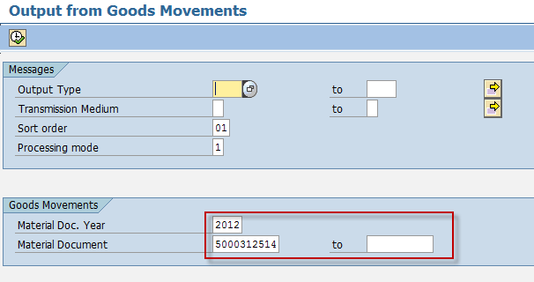

1. Click Execute  button.
2. In the succeeding screen, tick the check box before the material document field then click *Execute*  button.

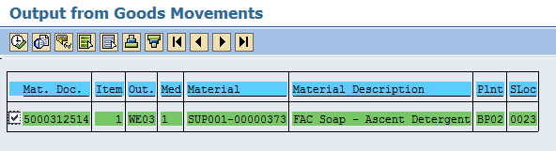

1. Click *Preview*  icon. A print preview is generated.

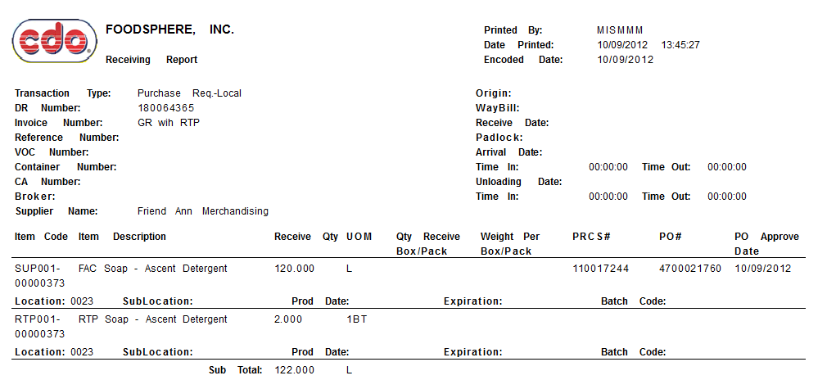

1. Click the Print icon to print the GR Slip.

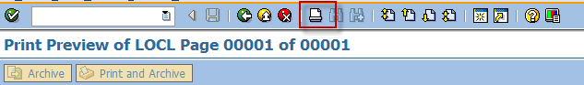

Result

A spool request has been sent to the printer.

# Goods Issue an RTP Material to Vendor

**Use**

This activity is performed to issue the stocks of an RTP material from warehouse to vendor.

Procedure

1. Access the transaction using any of the following navigation options:

|  |  |
| --- | --- |
| **SAP menu** | *Logistics* → *Materials Management* → *Inventory Management*→ *Goods Movement*→ *MIGO* |
| **Transaction code** | MIGO |

1. In the MIGO screen, choose **A07 - Goods Issue** with reference to **R10 - Other.**

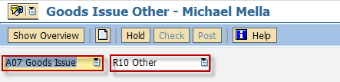

1. Make sure that the **movement type** at the right most part of the screen is **RE receipt to RTP 502 M**. Otherwise, type **502-M** in the box.

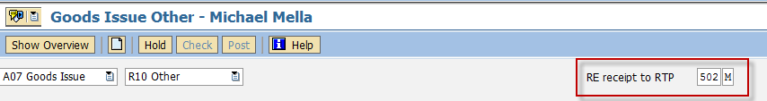

1. In the ***Header Data Area***, choose **General** tab and make the following entries as applicable:

| Field name | User action and values | Comment |
| --- | --- | --- |
|  | 3 Collective Slip | Print Active/Inactive |
| Material Slip |  | Required |
| Doc. Header Text |  | Required |

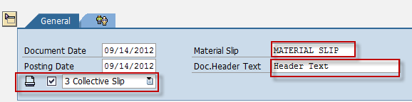

1. In the ***Detail Data Area***, choose **Material** tab and make the following entries as applicable:

| Field name | User action and values | Comment |
| --- | --- | --- |
| Material |  | Item code of the RTP Material to be issued/returned to vendor. Filter the list by material type **LEER - Empties** to narrow your search. |

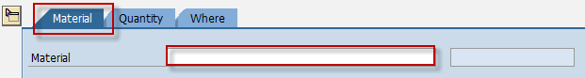

1. In the ***Detail Data Area***, choose **Quantity** tab and make the following entries as applicable:

| Field name | User action and values | Comment |
| --- | --- | --- |
| Qty in Unit of Entry | Numeric value | Quantity to be issued. |

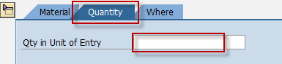

1. In the ***Detail Data Area***,, choose **Where** tab and make the following entries as applicable:

| Field name | User action and values | Comment |
| --- | --- | --- |
| Plant | Choose from the list | Plant code |
| Storage Location | Choose from the list | Location on where you wish to get the material being issued |
| Goods Recipient | Text value | Input additional name if necessary |
| Text | Text value | Input additional text if necessary |

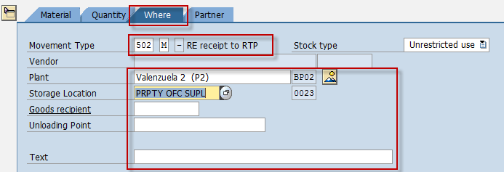

1. In the ***Detail Data Area***,, choose **Partner** tab and make the following entries as applicable:

| Field name | User action and values | Comment |
| --- | --- | --- |
| Vendor | Choose from the list | Specify the name of the vendor/supplier of the RTP item |

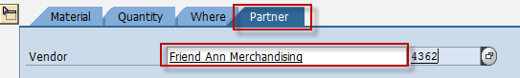

1. Tick the Item OK check box.



1. Click the *Check*  button.
2. A dialog box will appear containing system messages. Confirm all warning messages. Note that an **Error Message** will prevent you from posting the document.
3. Confirm messages by pressing **Enter**.
4. Click Save  icon or Post  button to post the document.

Result

1. Stocks on the inventory of the RTP material will decrease. You can check the inventory of the RTP material through transaction **MMBE** or **MB51**.
2. A material document is created for the issuance of goods/items.

