|  |
| --- |
| English |
| **Breakthrough Methodology**  **Business Process Procedure** |
|  |
|  |
|  |

Batch-to-Batch

Transfer Posting

### 

Project: CDO Foodsphere Inc.

Prepared By: Michael Mendoza Mella

Strictly Confidential

#### Icons

|  |  |
| --- | --- |
| Icon | Meaning |
| achtung | Caution |
| example | Example |
| tip | Note |
| recommen | Recommendation |
| syntaxic | Syntax |

#### Typographic Conventions

|  |  |
| --- | --- |
| Type Style | Description |
| Example text | Words or characters that appear on the screen. These include field names, screen titles, pushbuttons as well as menu names, paths and options.  Cross-references to other documentation. |
| **Example text** | Emphasized words or phrases in body text, titles of graphics and tables. |
| EXAMPLE TEXT | Names of elements in the system. These include report names, program names, transaction codes, table names, and individual key words of a programming language, when surrounded by body text, for example, SELECT and INCLUDE. |
| Example text | Screen output. This includes file and directory names and their paths, messages, source code, names of variables and parameters as well as names of installation, upgrade and database tools. |
| EXAMPLE TEXT | Keys on the keyboard, for example, function keys (such as F2) or the ENTER key. |
| Example text | Exact user entry. These are words or characters that you enter in the system exactly as they appear in the documentation. |
| <Example text> | Variable user entry. Pointed brackets indicate that you replace these words and characters with appropriate entries. |

#### 

#### Transfer Posting from Batch to a Batch of the same Material

(Batch-to-Batch Transfer)

Procedure

This transaction will be used by batch – batch trasnfer posting. This transaction will give the user the capability to transfer the stock(s) of an existing batch of a material to a new batch within a plant.

1. Access the transaction using the following navigation option:

**SAP Graphical User Interface (SAP GUI)**

|  |  |
| --- | --- |
| SAP menu | *Logistics → Materials Management → Inventory Management→ Goods Movement→ MIGO* |
| Transaction code | *MIGO* |

1. In the MIGO screen, choose **A08 Transfer Posting** and **R10 Other.**

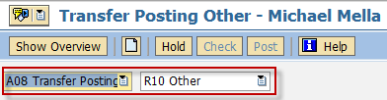

1. Make sure that the movement type at the rightmost part of the screen is **TF tfr ps.mat.to mat 309.** If not, type 309 in the field, the press Enter.

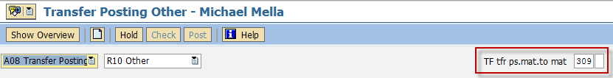

1. In the *General Tab Area*, make the following entries:

| Field name | User action and values | Comment |
| --- | --- | --- |
| *Material Slip* |  | Input is Required |
| *Doc. Header Text* |  | Input is Required |

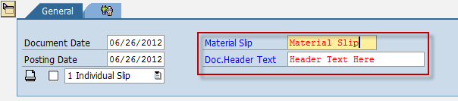

1. In the Transfer Posting Area, Choose *Transfer Posting* Tab and make the following entries:

| Field name | User action and values | Comment |
| --- | --- | --- |
| *From - Material* | Issuing Material | Input is Required |
| *Dest – Material* | Same value of *From - Material* | Input is Required |
| *From – Plant* | Issuing Plant | Input is Required |
| *Dest – Plant* | Same value of *From – Plant* | Input is Required |
| *From – Stor. Loc.* | Issuing Storage Location | Input is Required |
| *Dest – Stor. Loc.* | Same value of *From – Stor. Loc.* | Input is Required |
| *From – Batch* | Issuing Batch | Input is Required |
| *Dest – Batch* | Receiving Batch | Input is Required |
| *Unit of Entry* | Quantity to be transferred | Input is Required |

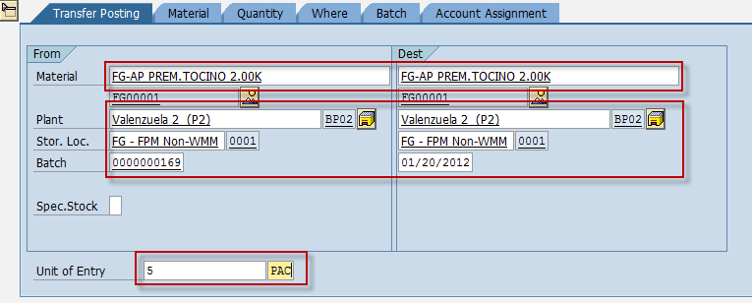

1. Tick.
2. Choose.
3. A dialog box appears containing system messages. Confirm warning messages. An error message will prevent you from posting the document.
4. Confirm messages by pressing Enter.
5. Post  or post.

Result

1. A material document is created.
2. The Unrestricted stock (quantity) of the issuing batch of material will be decreased and will be moved to the new batch.

#### Change/Flag for Deletion the Batch of a Material

**Use**

This activity is used to change/mark for deletion a batch of a material within a plant.

achtung Please make sure that the batch stock is empty (zero) on all stock type (Unrestricted, Quality Inspection, and Blocked) before flagging it for deletion.

Procedure

1. Access the transaction using any of the following navigation options:

|  |  |
| --- | --- |
| **SAP menu** | Logistics → Materials Management → Material Master → Batch → Change |
| **Transaction code** | MSC2N |

1. On the *Change Batch: Initial Screen*, make the following entries:

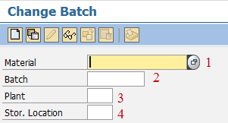

|  |  |  |
| --- | --- | --- |
| **Field Name** | **User action and values** | **Comment** |
| Material |  | Material Number |
| Batch |  | Batch to be set for deletion |
| Plant |  | Plant/Branch |
| Stor. Location |  | Storage location on which material is stored |

1. Press Enter.
2. On the Basic data 1 tab, make the following entries then press Enter:

|  |  |  |
| --- | --- | --- |
| **Field Name** | **User action and values** | **Comment** |
| Batch Deletion Flag | Tick check box - X | Indicator used to flag all data in a batch at client level for deletion. |
| Batch Deletion Flag at a Plant | Tick check box - X | Indicator that flags for deletion all the data on a batch at [plant level](SAPEVENT:DOCU_LINK\GL:plant). |
| Deletion Flag Batch Stock | Tick check box - X | Indicator the flags for deletion all data on a batch at [storage location level.](SAPEVENT:DOCU_LINK\GL:storage_location) |

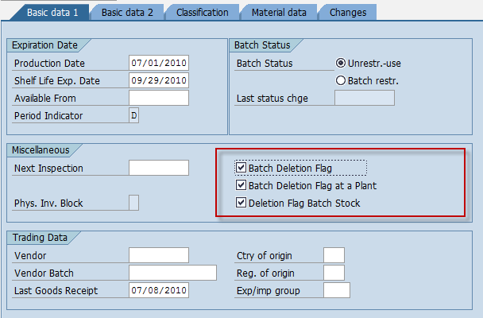

1. Save the changes on the material by pressing Save  or *Ctrl + S*.

Result

The batch of the material has been marked for deletion.