|  |
| --- |
| English |
| **Breakthrough Methodology**  **Business Process Procedure** |
|  |
|  |
|  |

Storage Location to

Storage Location

Transfer Posting

### 

Project: CDO Foodsphere Inc.

Prepared By: Michael Mendoza Mella

Strictly Confidential

#### Icons

|  |  |
| --- | --- |
| Icon | Meaning |
| achtung | Caution |
| example | Example |
| tip | Note |
| recommen | Recommendation |
| syntaxic | Syntax |

#### Typographic Conventions

|  |  |
| --- | --- |
| Type Style | Description |
| Example text | Words or characters that appear on the screen. These include field names, screen titles, pushbuttons as well as menu names, paths and options.  Cross-references to other documentation. |
| **Example text** | Emphasized words or phrases in body text, titles of graphics and tables. |
| EXAMPLE TEXT | Names of elements in the system. These include report names, program names, transaction codes, table names, and individual key words of a programming language, when surrounded by body text, for example, SELECT and INCLUDE. |
| Example text | Screen output. This includes file and directory names and their paths, messages, source code, names of variables and parameters as well as names of installation, upgrade and database tools. |
| EXAMPLE TEXT | Keys on the keyboard, for example, function keys (such as F2) or the ENTER key. |
| Example text | Exact user entry. These are words or characters that you enter in the system exactly as they appear in the documentation. |
| <Example text> | Variable user entry. Pointed brackets indicate that you replace these words and characters with appropriate entries. |

#### 

#### SLoc-to-Sloc Transfer Posting

(Storage Location to Storage Location Transfer)

Procedure

This transaction will be used in SLoc. to SLoc. Transfer . This transaction will give the user the capability to transfer the stock(s) of a material from the original storage location to a new storage location.

1. Access the transaction using the following navigation option:

**SAP Graphical User Interface (SAP GUI)**

|  |  |
| --- | --- |
| SAP menu | *Logistics → Materials Management → Inventory Management→ Goods Movement→ MIGO* |
| Transaction code | *MIGO* |

1. In the MIGO screen, choose **A08 Transfer Posting** and **R10 Other.**

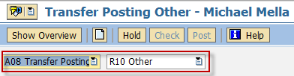

1. Make sure that the movement type at the rightmost part of the screen is **TF trfr within plant 311.** If not, type 311 in the field, the press Enter.

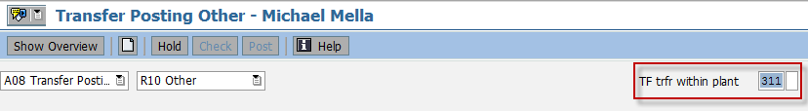

1. In the *General Tab Area*, make the following entries:

| Field name | User action and values | Comment |
| --- | --- | --- |
| *Material Slip* |  | Input is Required |
| *Doc. Header Text* |  | Input is Required |

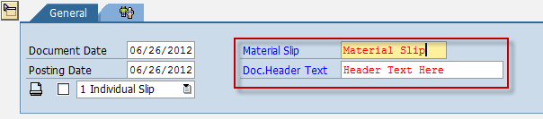

1. In the Transfer Posting Area, Choose *Transfer Posting* Tab and make the following entries:

| Field name | User action and values | Comment |
| --- | --- | --- |
| ***From*** |  |  |
| *Material* | Issuing Material | Input is Required |
| *Plant* | Issuing Plant | Input is Required |
| *Stor. Loc.* | Issuing Storage Location | Input is Required |
| *Batch* | Issuing Batch | Input is Required |
| ***Dest*** |  |  |
| *Stor. Loc.* | Receiving Storage Location | Input is Required |
| *Batch* | Receiving Batch | Input is Required |
|  |  |  |
| *Unit of Entry* | Quantity to be transferred | Input is Required |

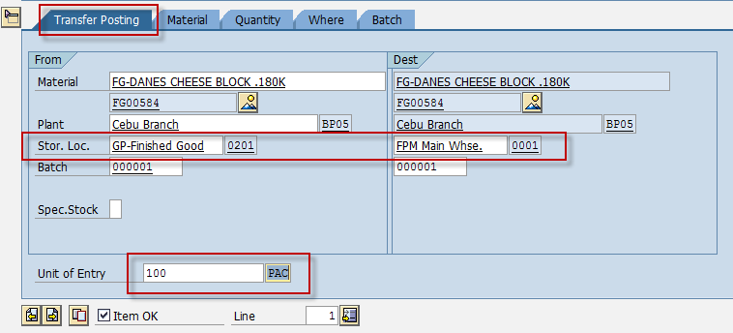

1. Tick.
2. Choose.
3. A dialog box appears containing system messages. Confirm warning messages. An error message will prevent you from posting the document.
4. Confirm messages by pressing Enter.
5. Post  or post.

Result

1. A material document is created.
2. The Unrestricted stock (quantity) of the issuing sloc. of the material will be decreased and will be moved to the new sloc.

tip If you want to reverse the transfer, follow the same steps above using the Movement Type **312.**