|  |
| --- |
| English |
| **Breakthrough Methodology**  **Business Process Procedure** |
|  |
|  |
|  |

Transfer Posting

From Warehouse

To Production Storage

### 

Project: CDO Foodsphere Inc.

Prepared By: Michael Mendoza Mella

Strictly Confidential

#### Icons

|  |  |
| --- | --- |
| Icon | Meaning |
| achtung | Caution |
| example | Example |
| tip | Note |
| recommen | Recommendation |
| syntaxic | Syntax |

#### Typographic Conventions

|  |  |
| --- | --- |
| Type Style | Description |
| Example text | Words or characters that appear on the screen. These include field names, screen titles, pushbuttons as well as menu names, paths and options.  Cross-references to other documentation. |
| **Example text** | Emphasized words or phrases in body text, titles of graphics and tables. |
| EXAMPLE TEXT | Names of elements in the system. These include report names, program names, transaction codes, table names, and individual key words of a programming language, when surrounded by body text, for example, SELECT and INCLUDE. |
| Example text | Screen output. This includes file and directory names and their paths, messages, source code, names of variables and parameters as well as names of installation, upgrade and database tools. |
| EXAMPLE TEXT | Keys on the keyboard, for example, function keys (such as F2) or the ENTER key. |
| Example text | Exact user entry. These are words or characters that you enter in the system exactly as they appear in the documentation. |
| <Example text> | Variable user entry. Pointed brackets indicate that you replace these words and characters with appropriate entries. |

#### 

#### Prerequisites

#### Check Stock Availability

**Use**

This activity is used to check the availability of stocks.

Procedure

1. Access the transaction using the following navigation option:

|  |  |
| --- | --- |
| SAP menu | Logistics → Materials Management → Physical Inventory 🡪 Environment 🡪 Stock Overview |
| Transaction code | MMBE |

1. On the *Stock Overview: Company Code/Plant/Storage Location/Batch Screen*, make the following entries:

|  |  |  |
| --- | --- | --- |
| Field name | User action and values | Comment |
| Material |  | Alphanumeric key identifying the material |
| Plant |  | Key uniquely identifying a plant |
| Storage Location | Optional. | Storage location at which the material is stored. |

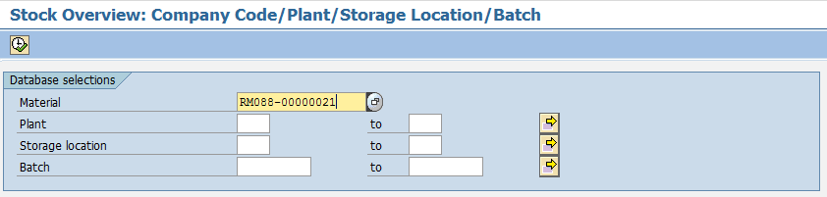

1. Click  icon to execute.
2. In the *Stock Overview: Basic List,* check on the stock level of the material to be reserved.

tip The column **Unrestricted Use** shows the stock available for use. This column will be your reference in determining if there are sufficient stocks for usage.

tip The column **Qual. Inspection** shows stock blocked for inspection.

tip The column **Reserved** shows stock currently reserved.

tip The column **Recpt Reservation** shows stock of confirmed reservation.

tip The column **On-Order Stock** shows number of stock on order.

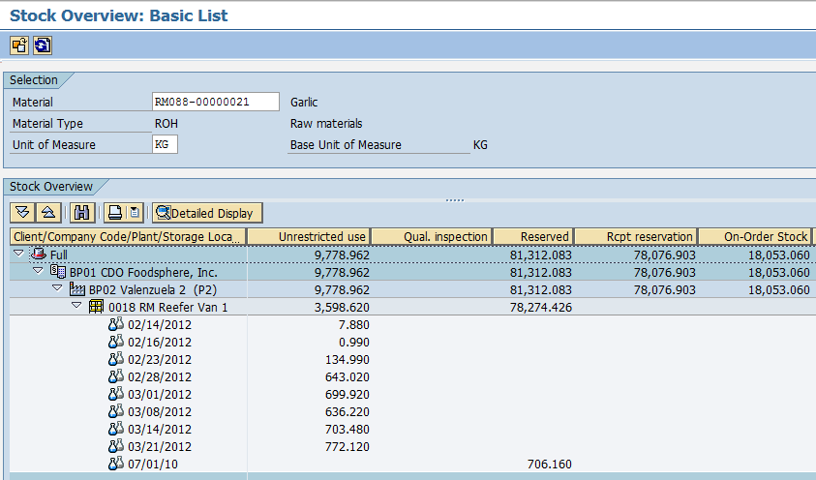

1. If the quantity is sufficient for your requirement, proceed to **Create Reservation: Transfer Posting Storage Location.**

#### Create Reservation for Storage Location Transfer Posting

**Use**

This activity is performed to create a reservation for Sloc-to-Sloc Transfer Posting.

Procedure

1. Access the transaction using any of the following navigation options:

|  |  |
| --- | --- |
| **SAP menu** | Logistics → Materials Management → Inventory Management 🡪 Reservation 🡪 Create |
| **Transaction code** | MB21 |

1. On the *Create Reservation* Initial Screen, make the following entries:

|  |  |  |
| --- | --- | --- |
| **Field Name** | **User action and values** | **Comment** |
| Base Date | Current Date | Specifies the date for which the goods movement is planned |
| Movement Type | **311 –** TF trfr within plant | Enter the code of the required movement type or choose a movement type from the list of [possible entries](SAPEVENT:DOCU_LINK\DS:GLOS.3526B36DAFAB52B9E10000009B38F974). |
| Plant | Choose from the dropdown list | Code of the plant that will receive or issue the goods. |
| **Reference** |  |  |
| Reservation |  | If you enter the number of an already existing reservation, certain data from that document will appear as default values in the reservation that is to be created. |

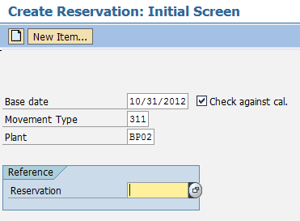

1. Press ***Enter*** key.
2. In the *Create Reservation: New Items screen* make the following entries:

|  |  |  |
| --- | --- | --- |
| **Field Name** | **User action and values** | **Comment** |
| Rcvg SLoc |  | Storage Location at which you wish to move the material |
| Goods Recipient |  | Specifies the recipient for whom the material is destined. |
| **Items** |  |  |
| Material | Choose from the dropdown list | Code of the material that you want to be reserved. |
| Quantity | Numeric value | Enter the quantity to be moved in any unit of measure for the material. |
| SLoc | Choose from the dropdown list | [Storage location](SAPEVENT:DOCU_LINK\GL:storage_location) at which the material is stored. |
| Batch | Choose from the dropdown list | Batch or valuation type of the material that is to be reserved. |
| M | Tick Box | If you want to prevent a goods movement in respect of this reservation item, you must deselect the field.  If you want to allow a goods movement in respect of this reservation item, select the field. |

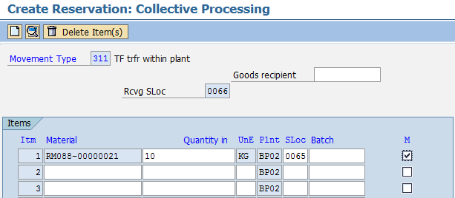

1. Click the *Enter* key*.* The screen moves to *Create Reservation: Details screen.* Otherwise, click the choose  icon.
2. In the *Create Reservation: Details screen,* make the following entries*:*

|  |  |  |
| --- | --- | --- |
| **Field Name** | **User action and values** | **Comment** |
| Requirement Date | Date value | Specifies the date on which the requested quantity of material is required. |
| Text | Indicate Meat Grade, if applicable | Contains an explanatory text on the line item. |

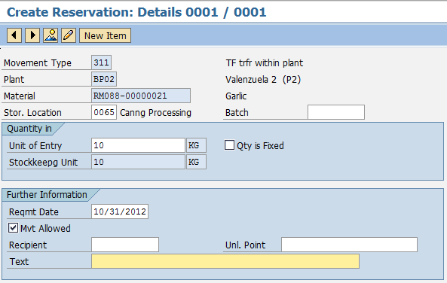

1. Click the Save  icon to save the reservation.
2. Note the reservation number that will be generated.

Result

Reservation for the material has been created.



#### Goods Issue to a Reservation

**Use**

This activity is performed to transfer goods to another storage location with reference to a reservation.

Procedure

1. Access the transaction using any of the following navigation options:

|  |  |
| --- | --- |
| SAP menu | *Logistics → Materials Management → Inventory Management→ Goods Movement→ MIGO* |
| Transaction code | *MIGO* |

1. In the MIGO screen, choose **A08 Transfer Posting** and **R09 Other.** Enter the reservation number on the space provided next to it.

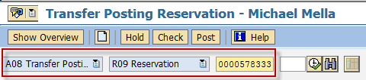

1. Make sure that the movement type at the rightmost part of the screen is **TF trfr within plant 311.** If not, type 311 in the field, the press Enter.

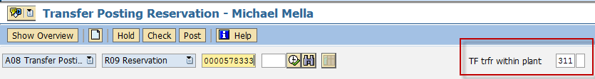

1. In the *General Tab Area*, make the following entries:

| Field name | User action and values | Comment |
| --- | --- | --- |
| *Material Slip* |  | Input is Required |
| *Doc. Header Text* |  | Input is Required |
|  | Tick Box - Checked | Choose 3 – Collective Slip |

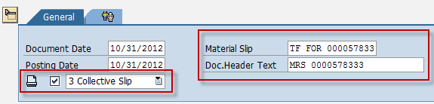

1. In the Transfer Posting Area, Choose *Transfer Posting* Tab and make the following entries:

| Field name | User action and values | Comment |
| --- | --- | --- |
| ***From*** |  |  |
| *Material* | Issuing Material | Input is Required |
| *Plant* | Issuing Plant | Input is Required |
| *Stor. Loc.* | Issuing Storage Location | Input is Required |
| *Batch* | Issuing Batch | Input is Required |
| ***Dest*** |  |  |
| *Stor. Loc.* | Receiving Storage Location | Input is Required |
| *Batch* | Receiving Batch | Input is Required |
|  |  |  |
| *Unit of Entry* | Quantity to be transferred | Input is Required |

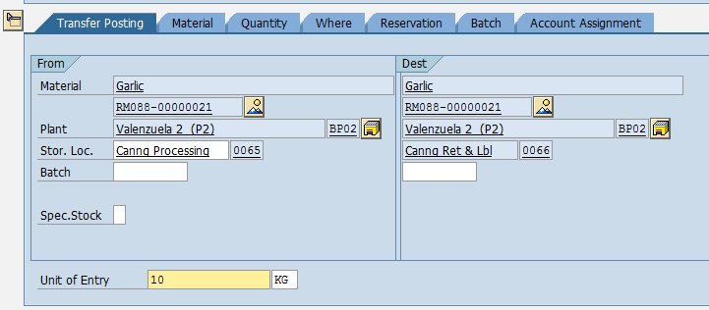

1. Tick.



1. Click  button.
2. A dialog box appears containing system messages. Confirm warning messages. An error message will prevent you from posting the document.
3. Confirm messages by pressing Enter.
4. Post  or post.

Result

1. A material document is created.



1. The Unrestricted stock (quantity) of the issuing sloc. of the material will be decreased and will be moved to the new sloc.

tip If you want to reverse the transfer, follow the same steps above using the Movement Type **312.**